mySDLC Delivery Process

Application Logical & Physical Solution Design
Project Name: On-Demand Portal for IAM Services
Project Control #: <Assigned RPM Number>
Responsible Parties
Prepared By | Department/Group | Region | Telephone
Umesh Waghode | Persistent Systems
Akriti Gupta | Persistent Systems
Contributors | Department/Group | Region | Telephone

Official Document Location
This document is stored at << Insert location path or hyperlink to SOR project Repository>>

Revision History
Version | Date | Author | Description of Revision
0.9 | 09/24/2018 | Umesh Waghode, Akriti Gupta | Work In-progress version
1.4 | 10/02/2018 | Umesh Waghode | Initial complete draft with all design contents
1.5 | 10/05/2018 | Umesh Waghode | Added QA Automation assumption, Attached Intake & Assessment Questionnaire
1.6 | 10/08/2018 | Akriti Gupta | Updated questions in OAuth2.0, OIDC, PA Site automation worksheets. Added note related to OAuth client secret handling.
1.7 | 10/12/2018 | Umesh Waghode | Warranty period update, Dinesh’s comment on user valuation during request/response and direct update in Database

Design Document Final Sign-Off Section
A signature indicates that you have reviewed and understand the contents of the document and attest to the validity of these contents relative to the functional role you are representing. If there are any aspects of this document that do not adequately reflect your needs or are deemed unacceptable, this should be noted in the comments section below your name.
Table 1. Final Sign Off Table – in order by role
Approved by
Engineering Team: Rajesh Bhabu/Dinesh Chinnasamy  Signature:  Comments | Date:
Architecture Team: Nitin Jaiswal, Calvin Kwan  Signature:  Comments | Date:
Build Team: Padma Kolli  Signature:  Comments: | Date
Integration & Onboarding Team: Kavita Todkar/Quan Le/Lina Costa  Signature:  Comments: | Date
Service Leader: Chirag Patel/Sasi Ramachandran/Antoine Ballard  Signature:  Comments: | Date
QA: Sridhar Manne  Signature:  Comments: | Date
ASG Operations: Prasanna Tadinada, Sophie Su  Signature:  Comments: | Date

Table of Contents
Application Logical & Physical Solution Design 1
1.1 Design Document Final Sign-Off Section 3
Table of Contents 5
2 Document Overview 9
2.1 Purpose 9
3 Project Overview 10
3.1 Project Summary 10
3.2 Project Scope 10
3.3 Definitions, Acronyms, and Abbreviations 12
3.4 Design Summary 15
3.4.1 System Context Diagram 15
3.4.2 Access to the portal 15
3.4.3 Application Management 16
3.4.4 Request Management 16
3.4.5 Request progress & Visibility 17
3.4.6 Roles & Responsibilities 18
3.4.7 Assessment 19
3.4.8 Data Model 19
3.4.9 IAM Automation (Integration) 19
3.4.10 Other integrations 20
3.4.11 Security 20
3.4.12 Deployment & Configuration 20
3.4.12.1 DNS Names and Load Balancers, Ports 20
3.4.13 Diagnostics 20
3.5 References 21
3.6 Dependencies 21
3.7 Design Assumptions 22
3.8 Design Constraints 23
3.9 Issues and Risks 24
4 People and Process Design 26
4.1 Actor/User View 26
4.1.1 Use Case Actors/Users 26
4.1.2 Event Response Diagram 27
4.2 People Components 33
4.2.1 Business Organization 33
4.2.2 Information Technology Organization 34
4.2.3 External Entity Organization 35
5 Logical Design 36
5.1 Application Module / Service View 36
5.1.1 Logical Component Diagram 36
5.1.2 : Application Module / Services Details 37
5.1.3 Application Module Configuration Details 48
5.1.4 Vendor Application Gaps / Customizations 48
5.1.5 User Interface Details 48
5.2 Component Realizations 59
5.2.1 << Insert Realization Title >> Sequence Diagram 59
5.3 Security 60
5.3.1 Authentication 60
5.3.2 Access Control 62
5.4 Volume & Performance Metrics 62
5.5 Information Availability and Disaster Recovery 63
6 Logical Data Model 63
6.1 Logical Data Model – Database Design 63
6.1.1 Application Profile 63
6.1.2 Onboarding Request 64
6.1.3 Sensitive Data Summary 66
6.2 Data Lifecycle and Retention Considerations 67
7 Solution Physical Design 68
8 Other Design Considerations 70
8.1 Request for Deviations/Waivers 70
8.2 Specialized Testing Needs 70
8.3 Solution Auditing Considerations 70
9 Appendix 72
9.1 Requirements Traceability 72
9.2 Open Source Package Dependency 74
9.2.1 Libraries used by On-Demand Portal’s backend services 74
9.2.2 Packages used by UI 75

List of Tables
[To update the list of tables, click inside it and press F9.]
Table 1. Final Sign Off Table – in order by role 3
Table 3. Definitions and Abbreviations 12
Table 4. Document References 21
Table 5. Design Assumptions 22
Table 6. Design Constraints 23
Table 7. Issues and Risk 24
Table 8. Use Case Actor Descriptions 26

List of Figures
[To update the list of tables, click inside it and press F9.]
Figure 1: System Context Diagram 15
Figure 2: Request State Transition 17
Figure 2: Use Case Actor/User view 26
Figure 3: Logical Component Diagram 36
Figure 4: Entity Relationship Diagram 66

Document Overview

Purpose
The Application Logical Solution Design (ALSD) document is critical to demonstrating how the requirements will be met by the proposed solution. It translates preliminary project objectives and concepts into functional and logical components that, when assembled together, form the total solution to the business problem. It is structured specifically to facilitate traceability to requirements by keeping in fidelity with standard requirement categories. It is a design-oriented document that presents logical views of solution components and how those components interact. It serves as the primary input to the Application Physical Solution Design (APSD) deliverable and process.
This document should be the single record of reference for how the logical components will inter-operate to form the total solution that pertains to this initiative. When completed, this document is placed under change control to preserve a record of what has been agreed to, and approved, for further solution design and development.

Project Overview

Project Summary
Kaiser Permanente’s Identity and Access Management (IAM) department within TRO wants to provide On-Demand Portal to enable application on-boarding to its services through a self-service at the same time also enabling IAM department to provide concierge services to business. The On-Demand portal will be designed and developed to digitize significant stages of the on-boarding process. The portal will enable Application Teams to initiate the on-boarding. At the same time, it will also provide concierge model such that representatives of IAM team can guide Application Team through the on-boarding process. Other important aspect of the portal is to automate the creation and promotion of configurations specific to IAM services.
There is a well-defined overall intake process defined to manually on-board any application to one or more of these services. This project will convert it into targeted questionnaire to derive specific application’s security requirement and be able to recommend specific configuration/integration with IAM services.
Both application team (Business) as well as IAM team will be able to initiate the on-boarding request as well as progress it fulfillment through collaborative efforts.
Building On-Demand Portal is one of the workstreams/deliverables of MFA Project's 7-1-1 Track (Internet-facing MFA)
This document is a sum of all the design related to the On-Demand Portal solution. The audiences for this document should have sufficient understanding of manual on-boarding process. Also, it is assumed that they have gone through the requirements definition document.

Project Scope
Refer “Requirement Traceability Matrix” to get list of requirements that will be met by this design.

This document describes the implementation details of the On-Demand Portal. The software will consist of below listed major functions:
- Manage Application Profile
- Raise and manage Onboarding request
- Assessment of application/business’s security requirements and map it to one or more IAM Services
- Assessment Report & Agreement
- Automate creation and promotion of configuration to Advance Central Authentication (ACA) platform, which provide central authentication service using PingFederate, PingAccess infrastructure
- Easy to use User Interface to perform functions like raising new on-boarding request, describe application and on-boarding request, define specific application need, respond to details required to fulfil the need, tracking progress of request, approving requests etc.
- User’s will be able to login to this portal through ACA based single sign-on.

The On-Demand Portal’s first version will enable all functions listed above for Advanced Central Authentication, which is one of the sub service from Central Auth. It is business decision to start enabling above functions to ACA as most on-boarding to ACA follow standard on-boarding and may not require any custom or more involved integration efforts.

Portal will support initiating on-boarding request for all IAM services however, automation will be only limited to ACA. Also, some of the orchestration that is usually required to enable creation & promotion of configuration will not be applicable to IAM services other than ACA.

Definitions, Acronyms, and Abbreviations

Table 2. Definitions and Abbreviations
Terminology | Description
IAM Onboarding Team | Different representatives from IAM organization perform different activities during the onboarding process. This document in general refers this team as IAM Onboarding Team.  Below are the roles & activities they own
  Service Leader Team | Performs ‘Assessment’ through Service Consultation Questionnaire.  Generates Assessment report consisting of recommended service, Cost, Timeline
  Integration Team | Performs ‘Fulfilment” through Solution Consultation Questionnaire  Creates configuration in Non-Prod environments  Raises CRQ to initiate promotion of configuration to PROD environment  Closes Onboarding Request after Production Warranty period
  ASG Operations Team | Approves promotion to PROD  Promotes configuration to PROD
ACA | Advanced Central Authentication is Central Authentication Service consisting of PingFederate, PingAccess and PingID MFA
Intake | Initial intent raised by Application Team. This is performed through TRO Website
On-board | The end to end process to understand application’s IAM need, recommend IAM services and configure recommended IAM service & application
Assessment | A stage in the overall on-board process where representative of IAM team will understand needs and identify relevant IAM services. This step is performed through series of Service Consultation Questionnaire
Fulfillment | A stage in the overall on-board process where IAM Integration team will establish the technical facts required to configure recommended IAM service.  This step is performed through series of Solution Consultation Questionnaire  Fulfilment will go through series of steps like collecting inputs related to ACA standard onboard, create configuration in Non-PROD, promote configuration to Non-PROD and eventually to PROD, which will be performed by ASG Operations Team.
Service Consultation Questionnaire | Set of questions posed to Application Team to better understand application, application’s current state with respect to IAM use cases and feasibility questions. Based on this Service Leader Team can identify applicable IAM services.
Solution Consultation Questionnaire | Set of questions posed to Service Leader to identify the platform/model like SAML, OAuth 2.0, OIDC, PA, most suitable for the application.
Integration Consultation Questionnaire | Set of technical questions pertaining to given IAM service to identify specifics of actual configuration to be created in the given IAM service. This step will be performed by IAM Integration Team.
Automated on-board | The configuration identified through Solution Consultation Questionnaire could be created automatically at the given IAM service
TRO | Technology Risk Office
IAM | Identity and Access Management
BIO | Business Information Owner(s)
BAO / D | Business Application Team / Designee (s)
SME | Subject Matter Expert
KPIM | KP Identity Manager
CAPS | Centralized Access Provisioning Service
TNS | Termination Notification Service
CARMA | Certification of Access and Role Management Application
QAR | Quarterly Access Reviews
ACL | Access Control List

Design Summary

System Context Diagram

Figure 1: System Context Diagram
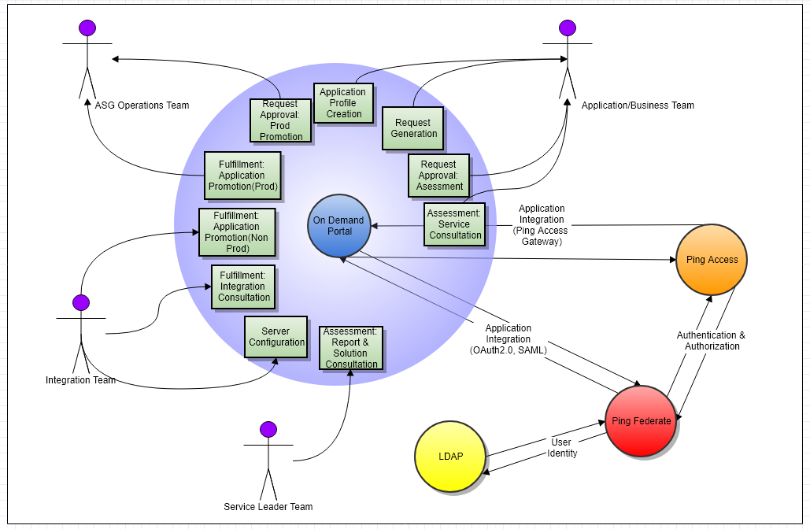

Below sub-sections provide the high-level summary of various aspect of the OnDemand Portal.

Access to the portal
OnDemand portal will consist of a user interface that will be served by a web server. Portal will be accessed using DNS name exposed by IBM Cloud for the host on which portal is deployed. This could be a load balancer URL.

On-Demand Portal UI component will be protected by PingAccess.

Alternative approach of protecting On-Demand Portal directly by PingFederate was considered. However, as On-Demand Portal may be enhanced in future to enable more features & functionality, it might be better to utilize PingAccess to enforce coarse-grain authorization.

The configuration in PingAccess for On-Demand Portal as its initial version will not enforce any authorization rules at PingAccess. However, PingAccess by its core behavior, will ensure that only authenticated users are using the system.

As portal does not maintain any sensitive information about the user, it would be appropriate to allow seamless login to the portal. OAuth 2.0 server configuration as well as authentication policy configuration in PingFederate should be such that it enforces seamless authentication for authentication request from PingAccess for On-Demand Portal.

Refer Security section for more details.

Application Management
Both Application team members or IAM team members can create/update profile for the business application.

Application Team member will be able to see applications that they own.

All user’s will be able to see all onboarding requests associated with the application from the application management screen

Information about the application that is important from assessment point of view will be mandatory while creating the application profile.

The attached worksheet “Intake and Assessment Questionnaire” contains application profile attributes that will be collected from the user to gather all relevant information.

Worksheet “Attribute Mappings Application Profile” contains all application attributes from ATLAS along with mapped questions. This sheet also contains high level mapping of these attributes with database entity. During the development the sub set of these will be fine-tuned through incremental demonstrations of the User Interface.

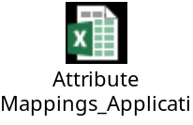

Request Management
IAM Onboarding team member will be able to raise onboarding request on-behalf the business user. Application team member can as well raise onboarding request on their own.

As described in “Roles & Responsibilities” section, Application Team member will be able to respond to assessment questionnaire, but the assessment report will be generated only by IAM Onboarding Team member (Service Leader Team).

Application Team members can view, update onboarding requests that they own. Onboarding requests of other business will not be visible.

Design details in this document will describe in detail the Request State Transition, status/progress reporting on the user interface etc. Design will also capture information that will be derived/auto populated from other sources like Application Profile.

The attached worksheet contains intake questionnaire for request related details along with high level database mapping

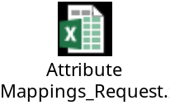

Request progress & Visibility
This design document will capture specific information/insight that Portal will display on the dashboard. The set of information that will be displayed on the Dashboard for Application Team member will be limited to the applications and onboarding requests that they own however, IAM Onboarding Team member will see statistics across all applications and onboarding requests.

Below image captures request state transition:

Figure 2: Request State Transition
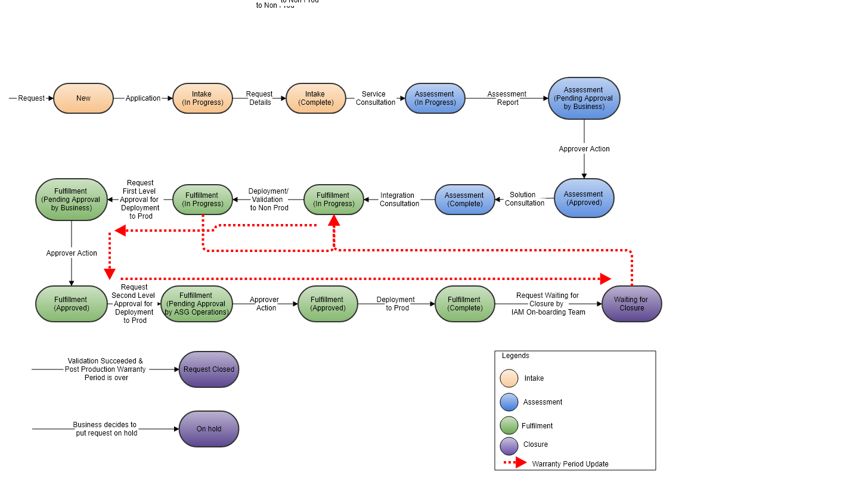

Roles & Responsibilities
On-Demand Portal will only support two Roles (a.k.a Personas).
- Application team member (Business user is any member from the application team, could be BAO, BAOD, Technical contact)
- IAM Onboarding team member (any user from IAM department)

As explained above, portal will identify if the logged in user is from IAM department. It will do so based on the attribute in Access Token. All other users will be considered as business users.

All features of the portal will be available to IAM department user. Portal will not enforce separation of duties within IAM department users for any operation except the production approval action. Production approvals will be allowed only to ASG Operations team.

Below are the functions that will be available only to IAM department users;
- Generate Assessment Report & Recommendation
- Integration fulfilment questionnaire
- Creating and promoting configuration to ACA
- Changing system configuration of the OnDemand Portal
- Marking Onboarding request to Complete status

Onboarding request will contain attribute that will hold contact details of the person responsible for specific actions. All ASG Operations team members will always be attached to each onboarding request.

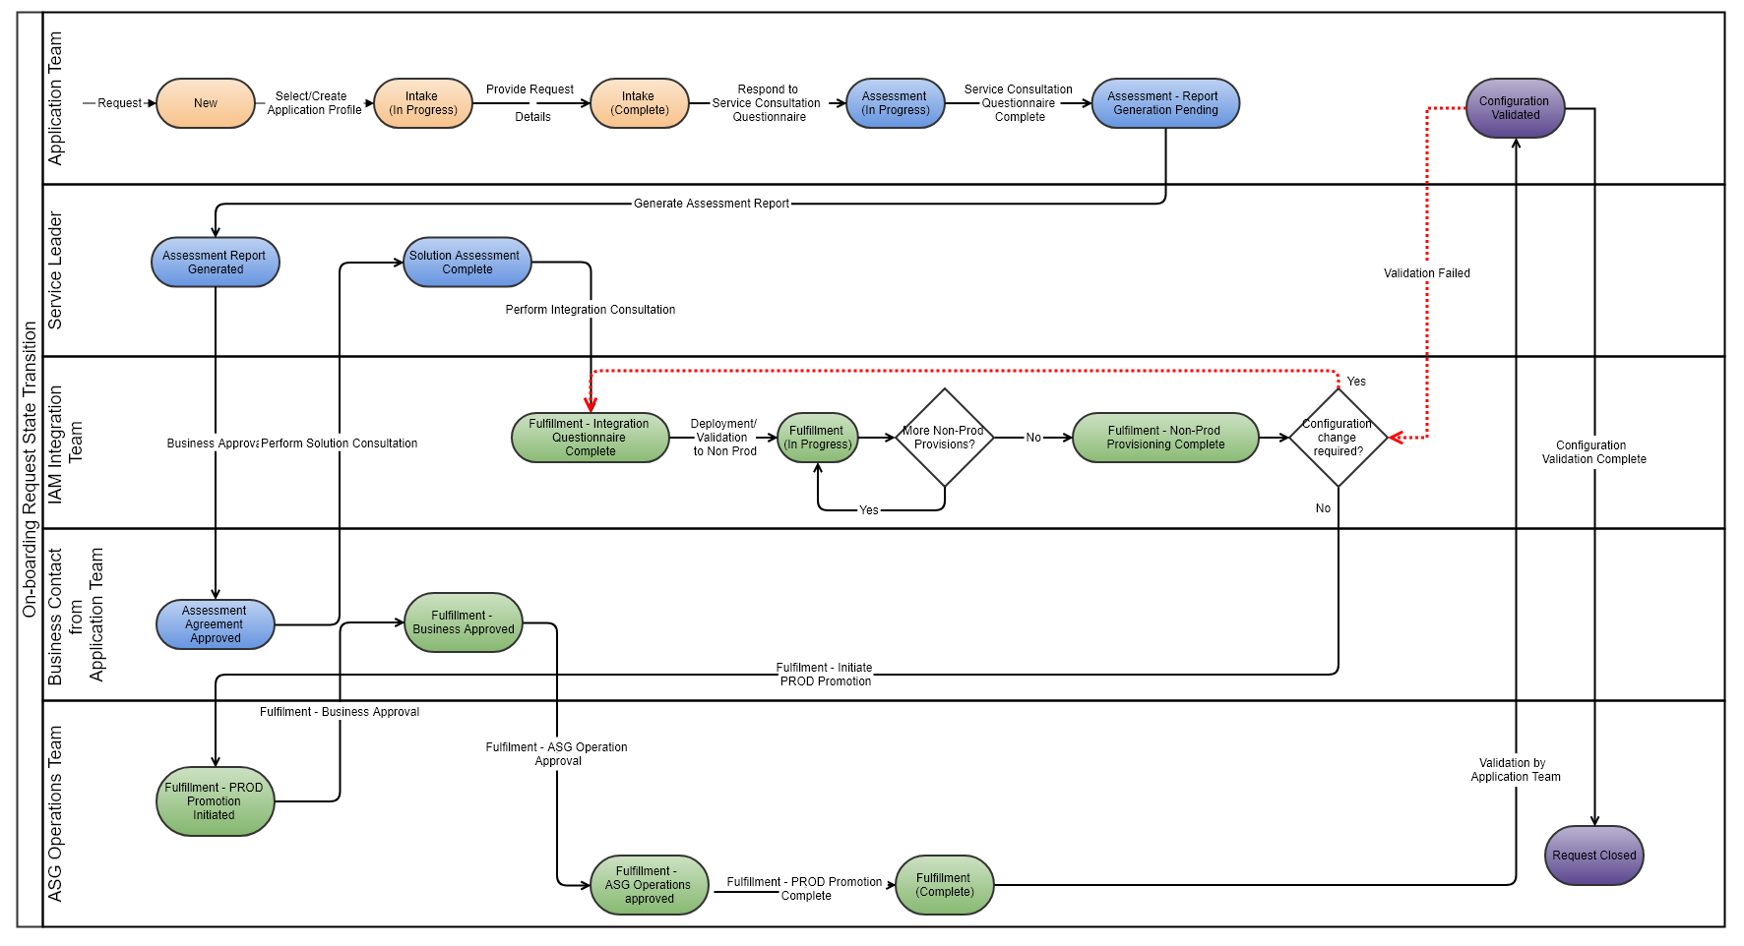

Assessment
Assessment is the process where through set of questionnaires, service leader will identify IAM service that can fulfil the specific security need of the application. The result of the assessment process will result into below two recommendations:
- IAM Service that application should be onboarded to.
- The specific integration platform/model that the recommended IAM Service support that is most suitable for the application.

Along with the recommendation, assessment summary will contain details about level of efforts, cost and timelines. However, these details will be pre-defined values for type of service and integration model. Portal will not define and evaluate cost, timeline etc.

This design document will capture set of questions that will be presented in the user interface as well as the sequence in which these are prompted.

Refer links provided in the References section.

Attached below is the Solution Consultation Questionnaire that will be used to determine if it is ACA standard on-board or custom.

Refer links provided in the References section.

Data Model
Below are the entities for which this document captures detailed ERD diagram.
- Application Profile
- Onboarding Request
- Onboarding Request state definition & transition
- Onboarding team contacts
- Onboarding request action ownership
- Application to Request association
- IAM Artifacts
- Request to IAM Artifacts association
- Application’s lifecycle
- Provisioning progress for each application lifecycle

All of these objects will be managed via user interface. User interface will use Restful API. As such there is no need, but Restful APIs can also be invoked by client other than On-Demand Portal. Database design is extensible to accommodate new attributes pertaining to above listed objects.

Hence, as such there will be no need to update the data in the database directly. That said, certain data, for ex. Change of technical contact for application could be updated manually in the database. Such direct update in database is not recommended and will have to review on needed basis. If it is concluded through review that such a change will be frequent, recommendation will be to enhance the Portal than encouraging direct manual updates in the database

Refer Logical Data Model section for more details.

IAM Automation (Integration)
As described in the “Project Scope”, onboarding to ACA sub-service from Central Auth Service will be automated where artifacts or configuration will be created in ACA by the portal automatically.

The automation will also cover creating such configuration in lower environment and then promoting it to other higher environments.

The design details will cover details like
- Artifact/configuration creation in designated initial environment
- Promotion to designated highest environment from list of all non-prod or lower environments, which is MUST to initiate promotion to PROD
- Approval flow involved in promotion to PROD
- Kaiser Permanente’s standard for each integration model
Refer “Automation” section for more details.

Other integrations
Besides integration with PingFederate to enable SSO, this design will also capture details specific to meet following integration requirements
- Create work order and CRQ in ServiceNow
- Send email notification about the progress of the request
- Upload document associated with the onboarding request
Refer “Integrations” section for more details.

Security
On-Demand Portal component communication will be over TLS 1.2. On-Demand portal will maintain service account credentials to ACA, which it will maintain in encrypted form.

Refer Security and Sensitive Data Summary sections for more details.

Deployment & Configuration
On-Demand Portal’s components will be deployed on Kaiser Permanente’s virtual private cloud based on IBM Cloud.
On-Demand Portal’s user interface application as well as the backend services layer will have set of configuration and data files.

Refer Physical Solution for more details.

DNS Names and Load Balancers, Ports
To deploy the On-Demand Portal certain system requirements like DNS name, load balancer, firewall configuration to open ports etc. will be required.

This design capture relevant information in respective section.

Refer Physical Solution for more details.

Diagnostics
On-Demand Portal core component is its backend services layer, which is implemented as set of Restful interfaces. User Interface will perform functionalities by invoking these Restful APIs.

User Interface will have minimal diagnostic logging that indicates if the service is start properly and that it is able to communicate with backend services.

The backend services layer will log events at various log level capturing information useful to diagnose issues. Backend service being a Java based layer, it will use log4j module to writes logs into a file.
It will make use of log4j configuration file to set the log level to more detailed level in case more debug information is needed to diagnose the issue. Default log level will be “Info”.

Diagnostics from IBM Cloud point of view is beyond the scope of this document.

References

Table 3. Document References
Title | Version | Author | Location
Service and Solution Consultation Questionnaires |  | Chiragkumar Patel, Antoine Ballard | https://forms.office.com/Pages/ResponsePage.aspx?id=xHuKPzfjpUeg_A1RLA4F8XaiDW1yFQZLkLyeTU8PPn5UNTJDR1BTWEFBOVJBSTZQSFVSRk1CQzZCMC4u  https://forms.office.com/Pages/ResponsePage.aspx?id=xHuKPzfjpUeg_A1RLA4F8XfvgZPcb6JFtnDGxRrOvGRUMFdITjFMSUNKVUhCWDE2STVPTkJKSVUwWS4u

Dependencies
- PingFederate configuration required to protect On-Demand Portal using PingAccess. Details are captured in Security section.
- PingFederate configuration required to enable automatic creation of artifacts like SAML Service Provider Connection, OAuth 2.0 Client and PingAccess Site required to complete fulfilment for the application being onboarded. Refer Automation section for more details.
- Integration between PingFederate and PingAccess to enable automatic creation of artifacts like PingAccess Application, Site & their related artifacts.
- Availability of ServiceNow service integration API/Source code from KPIM team.
- Availability of Email service integration API/Source code from KPIM team.
- Availability of specific design requirements and resolution to be able deploy On-Demand Portal’s components in IBM Cloud, which otherwise are being developed for deployment on standalone servers.
- Service Consultation and Solution Consultation will be provided by Service Leader team

Design Assumptions
Table 4. Design Assumptions
Component or Process | Assumptions
Automation | Design will identify standard set of integration related details that will be prompted from the user and the automation will be limited to creating the artifact corresponding to the integration model. However, if the artifact creation depends on ACA product’s certain configuration, this design assumes that all such configuration is created upfront in ACA and that such configuration will be common to any application that will be onboarded through the portal.  For ex. A) PingAccess and PingFederate should be integrated B) Specific Adapters, authentication policies, authentication policy contract, Oauth authorization server settings & similar configuration is created upfront in PingFederate.
Automation | After discussion with Service Leader & Architecture team, standard configuration for SAML2.0, OIDC/OAuth2.0 and PingAccess Site has been identified in this design.  If business application need is not met by the standard configuration, on-boarding will be treated as custom/manual.  It is understood that there will not be many such outliers. The success of this design does not depend on the number of such outliers.
ACA | This design assumes PingFederate version 8.4.4 and PingAccess version 4.3.  To support higher version of PingFederate and PingAccess, changes required will be about any changes in the Admin APIs exposed by these products and if upgraded ACA intend to use specific features introduced in higher versions.
Users | On-Demand Portal is meant to be used only by IAM Onboarding team and Application Team. However, any KP user can login that has got account in KP Identity Store can access the portal. On-Demand Portal will not stop any such access.
Onboarding Request’s fulfilment for all IAM services apart from ACA | This design assumes availability of ready to use ServiceNow API/source code with required inputs preset to create work order  This design will assume reusing utility code from KPIM and relies on it for the core of ServiceNow integration.  In the event this dependency is not met, Portal will just display message to the user that ServiceNow work order need to be raised. The request will remain in in-progress status while the onboarding is being performed manually.
Email notifications | This design assumes availability of ready to use API/Source code/Configuration to send emails.  This design will assume reusing utility code from KPIM and relies on it for the core of SMTP based email notification.  It is also assumed that email will use basic text-based templates for sending notification and will not support attachments. More details are captured in later section.
Deployment | KP’s IBM Cloud Organization has specific guidelines/pre-requisite that must be followed/fulfilled by the team requesting infrastructure & service from KP’s IBM Cloud organization. Any such effort is beyond the scope of this design
ACA API Connectivity | It is assumed that PingAccess and PingFederate Admin API are protected by these product’s native authentication method.  There is alternative way to protect both set of Admin API using PingAccess Site based configuration or by any other Gateway products.  Design will need to be updated if above assumption is not true.
Service Accounts | Service accounts for products PingFederate, PingAccess, ServiceNow, KP SMTP Mail server will be available.
ACA Usage | On-Demand Portal will access PingFederate and PingAccess using fam.kp.org and wam.kp.org GTM respectively. It is expected that if the request gets routed to different other active data center or other nodes within the data center, it is assumed that ACA will ensure that configuration created is replicated on real-time manner.  Any issues resulting due to such issues will not define the success of this design.
QA Involvement | On-Demand Portal will create integration artifacts at ACA as per the predefined standard configuration. There will not be any custom effort involved during in the integration created through the portal. Hence, it is assumed that QA Team will not be required to perform testing of the integration.

Design Constraints

Table 5. Design Constraints
Component or Process | Design Constraint
Open Source Library/Packages usage | Kaiser Permanente’s management team need to approve Open Source Library/Packages dependency of the solution components. None of these packages are GNU Public License. All other Open Source licenses allow free distribution and use of the library in production. Please refer Appendix section for more details.
On-Demand Portal’s Backend Service Layer | On-Demand Portal’s service layer, which is Restful services are being developed using various open source libraries like Spring 4, Hibernate, Jackson, Log4j etc.  IBM Cloud provided web container and runtime environment could pose restrictions/constraints to the extent that deployment could fail.  This design assumes that in such event will be on On-prem infrastructure which will consist of Linux hosts with Tomcat web container.
Deployment of the solution | It requires specific deployment planning and effort when any on-premise workload is to be migrated to Cloud. It requires even more consideration when the workload migration must adapt PaaS service provided by the chosen cloud platform.  This design does not assume any effort in designing, packaging the deliverable as IBM PaaS cloud deployment ready component.  It will require effort outside of this design to complete deployment necessities both from technical requirement as well as KP’s IBM Cloud Team’s processes.  This design will deliver solution that can be deployed on Linux hosts where required container’s, runtime environment will be manually installed.
High Availability / Failover | By the nature of the application, it is understood that there will not be high load. If the disaster recovery class of service requires deployment to be highly available and support failover within datacenter, GTM, LTM for the webui component must support client IP address-based affinity.
On-Demand Portal System Requirement | On-Demand Portal will require RHEL7 64 bit, Oracle JRE 1.7+, Postgres DB, NodeJS environment, Web Container  Resource requirement: - 8GB RAM, 2 CPU Cores  Network requirements like a) Load Balancer b) Firewall configuration for to open communication on required ports
On-Demand Portal client requirement | On-Demand Portal will be best used in latest version (as of date) of Chrome and Firefox browser.  Though user interface will work perfectly on other browsers, this design does not include any effort to validate it on browser apart from listed above.

Issues and Risks

Table 6. Issues and Risk
Component or Process | Issue or Risk and Mitigation Plan
Deployment | Infrastructure required must be prepared parallel to the design/development activity so that infrastructure is ready by the time build is ready for deployment
Network | Infrastructure team should prepare for requirements like TLS1.2, Load balancers, Port opening,
Automation | Automation depends totally on the Restful Interfaces supported by PingFederate and PingAccess. If there is any bug or limitation in the said versions of these products, it can pose limitations on certain aspect of automation. Such cases will have to be handled individually and may impact timeline as well as the scope.
Service Account | All required service accounts must be available for each environment.
IBM Cloud | Solution will be down or will not be able to fulfil user request if there is any connectivity issue to IBM Cloud or connectivity from IBM Cloud to other on-premise components like ACA.
ACA | This solution depends heavily on the availability of ACA.

People and Process Design

Actor/User View
Figure 3: Use Case Actor/User view
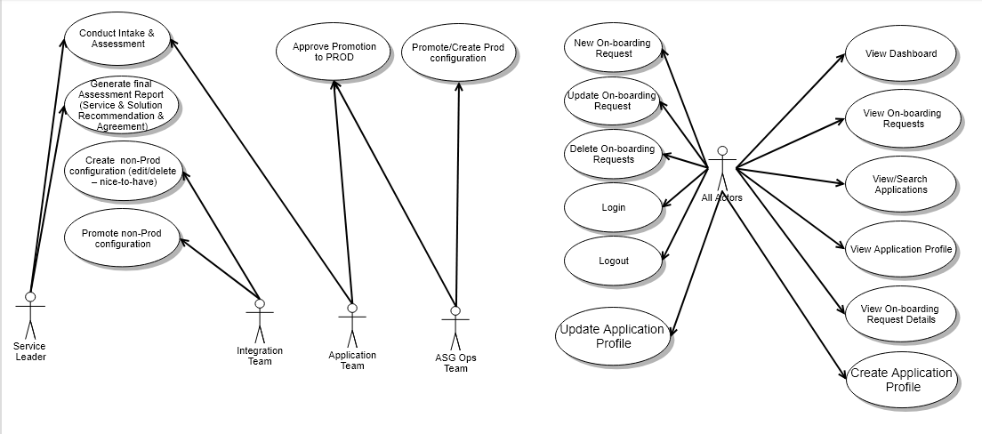

Use Case Actors/Users
Table 7. Use Case Actor Descriptions

Actor | Team for | Description
Application Team | Persona in On-demand portal who represents BIO or BAO or BAOD or Technical Contact or Dev Manager | The user from the business side could  - raise onboarding request  - respond to Service Consultation Questionnaire  - supply any other information requested by IAM Onboarding Team  - approve assessment report resulting from Service and Solution Consultation Questionnaire
IAM Onboarding Team | Persona in On-demand portal who is representative from IAM teams (Service Leaders for Intake & Assessment, Integration Team for Fulfilment &, ASG Operations Team for promoting configuration to PROD) | IAM Onboarding Team will  - provide concierge services to Application Team  - conduct assessment through Service Consultation Questionnaire on behalf the Application Team  - will respond to Solution Consultation Questionnaire based on the information supplied by the Application Team  - administer the On-Demand portal

Event Response Diagram
Use Case 1: Application Profile Creation, Request Intake & Service Consultation Assessment

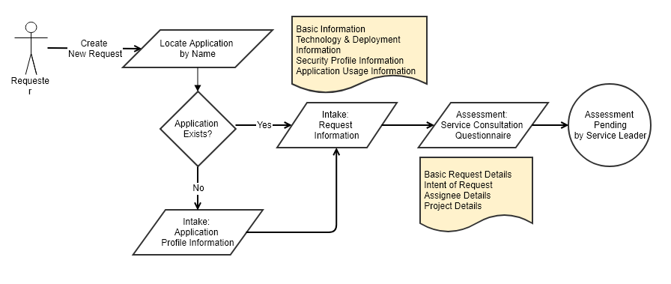

- Requestor from Application Team creates a new Request.
- Enters the Application Profile and its details.
- Enters the Request details like intent, assignees.
- Answers the Service Consultation questionnaire
- As requester is from Application Team, he/she cannot progress the on-boarding request further. At this point, Service Leader would review responses to Service Consultation Questionnaire and submit assessment report for approval by Business Contact. Refer Use Case 2 below. However, if the requester is from IAM On-boarding team, the flow will seamlessly continue to Use Case 2.

Use Case 2: Generation of Assessment Report

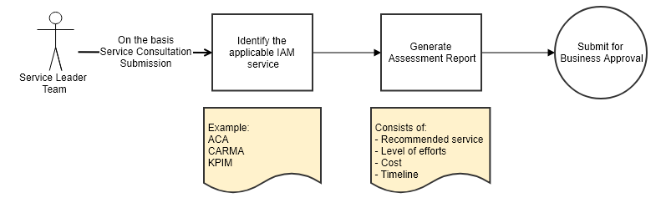

- Service Leader identifies the applicable IAM service based on submitted Service Consultation.
- Generates the Assessment Report which contains details of recommended service, level of efforts, cost & timeline.
- Submits the report for Business approval.

Use Case 3: Approval of Assessment Report by Business

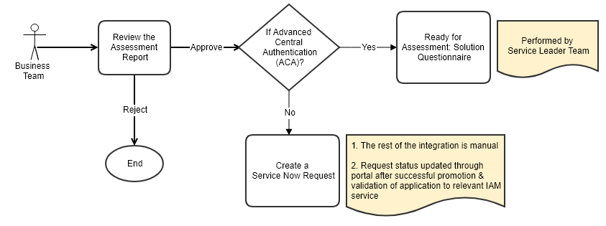

- Business Contact reviews the Assessment Report and approves/rejects it.
- If the assessment is approved and if the recommended service is ACA, the request moves for Solution Consultation stage which will be performed by Service Leader from IAM Onboarding Team.
- Post successful approval, if assessment results in services other than ACA, then portal will create a work order in ServiceNow. All subsequent configuration for this request will be done manually by IAM Integration team and operations team. After successful integration to production, request can be closed in the portal manually.

Use Case 4: Assessment: Solution Consultation

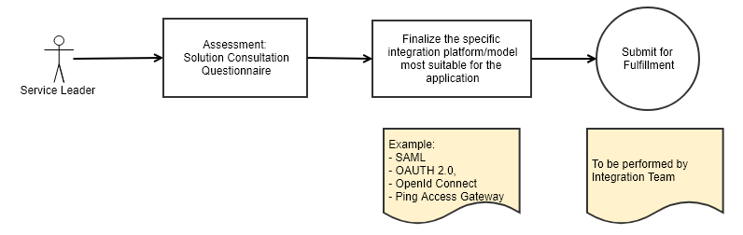

- Service Leader finalizes the integration platform/model (like SAML, OAuth 2.0, OIDC, PA) which is most suitable for the application.
- Submits the request for Fulfillment to be performed by Integration Team.

Use Case 5: Fulfillment: Integration Consultation & Promotion to Non-Prod IAM deployment

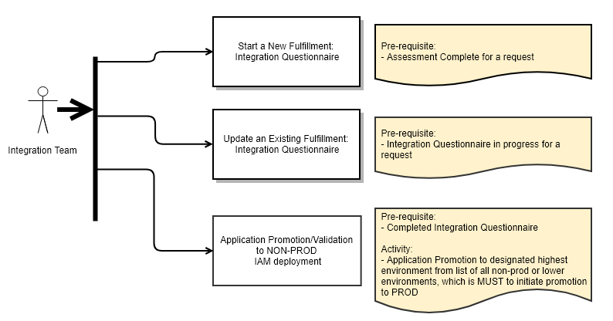
- Integration Team can perform below actions:
  - Answer the Integration consultation questionnaire.
  - Update an existing integration consultation
  - After successful completion of integration consultation, promote application lifecycle (in desired order) to Non-Prod IAM deployment.
  - Applications can be promoted in any order of their lifecycles, however, before Prod promotion, at least one (must have lifecycle) needs to be promoted and validated in Non Prod deployment. Lifecycle information is captured during application profile creation.

Use Case 6: Fulfillment: Prepare for Prod IAM deployment Promotion & Submit for Approval

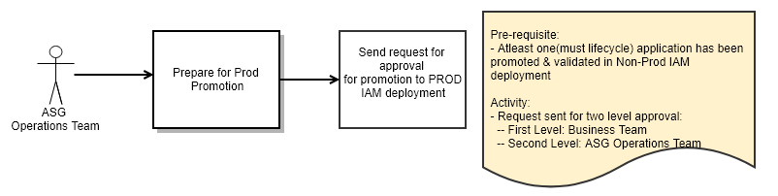
- ASG Operations Team prepares the environment for promotion of application to PROD IAM deployment. This activity involves taking back up existing configurations etc.
- The request for promotion is sent for approval.

Use Case 7: Fulfillment: Approval from Business Team & ASG Operations Team

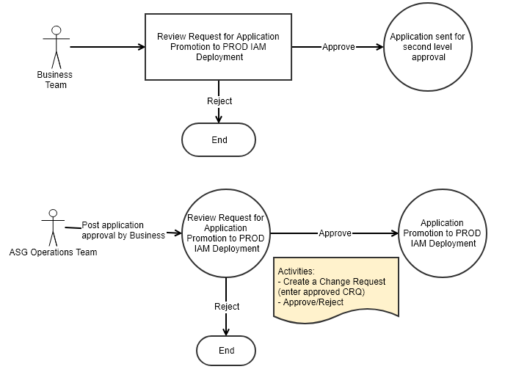

- Business Contact reviews the request. They can either approve or reject the request.
- After successful approval by Business, the request is sent for second level approval to ASG Operations Team.
- ASG Operations Team reviews the request. They can either approve or reject the request.
- For successful approval, ASG team needs to update the request with an approved CRQ number.

Use Case 8: Fulfillment: Promotion to Prod IAM Deployment

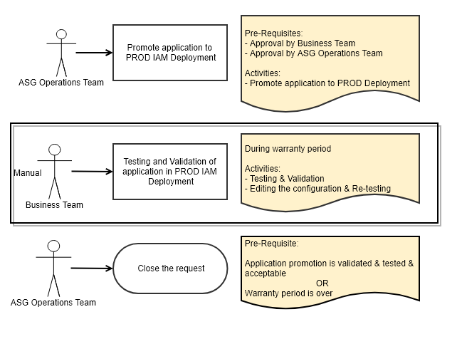

- ASG Operations team promotes the application to PROD IAM deployment.
- Application Team performs manual testing and validation of the promotion during warranty period. In case of issues, they can request for change in configuration. The process will follow all previous fulfillment steps. Any such change will start all over again from Integration Questionnaire where actual change in configuration will be made and non-prod promotion will begin from initial environment and then to other non-prod environments before re-initiating process for PRDO promotion.
- ASG Operations Team can close the request:
  - If the application promotion is deemed valid and successful by Business Team, or
  - Warranty period is over

People Components
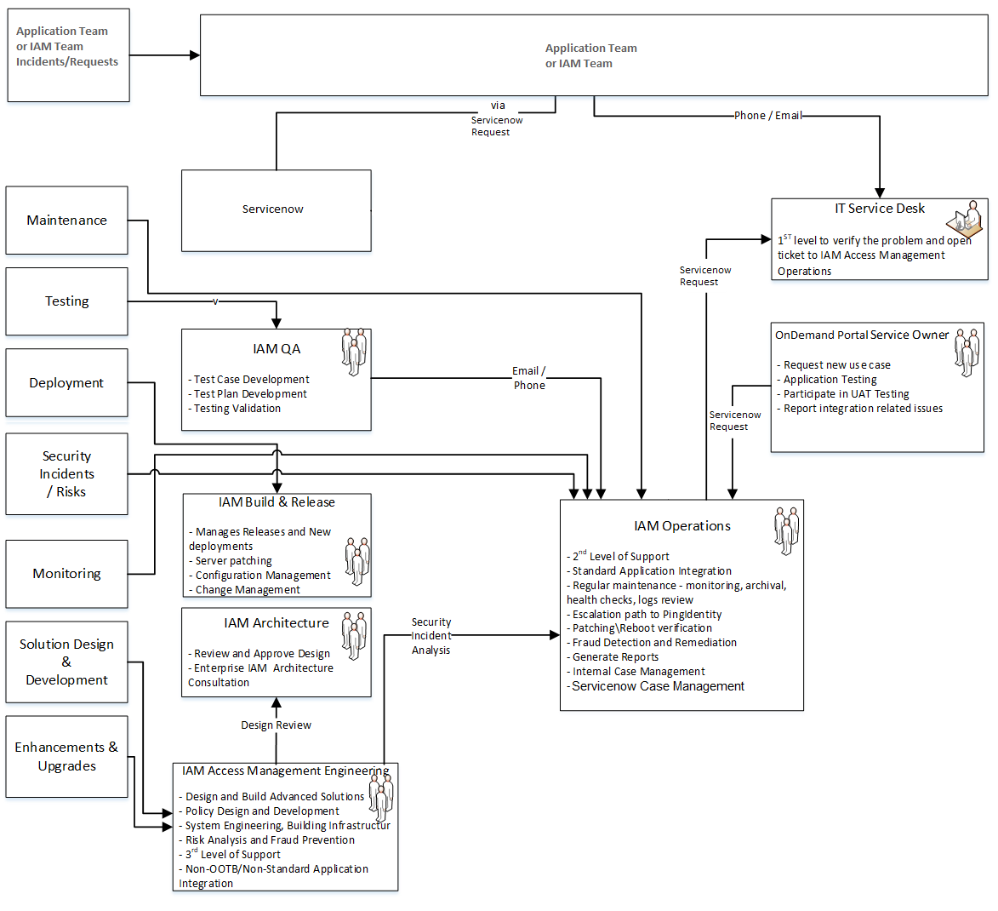

Business Organization
  - Business organization is the consumer of the On-Demand Portal
  - Business Application Owner or designated member from this organization will identity the need and contact TRO organization
    - Application team can optionally go to TRO website or directly contact Business Enablement team about their need. The business enablement team will redirect application team to On-Demand Portal
    - The On-Demand portal will also be published to the KP organization.
  - Representative from the application team will identify the technical contact and a delegate who will be responsible to provide information required by the IAM Onboarding Team.
  - Business Application owner or designated business contact & their delegate will approve
    - assessment report & agree to initiate the fulfilment of the request
    - the promotion to production environment and post promotion to IAM environment, agrees to ensure that application team will perform testing

Information Technology Organization
IAM Service Leader Team
Service Leader has two roles to play:
- Consumer of the On-demand Portal
- Product owner of the On-Demand Portal

As a consumer, Service Leader organization will work with the requester from the application team (business side) to
assess application’s exact security need. Based on the service & solution questionnaire-based interview Service Leader will submit assessment report containing recommended IAM service & Platform along with the associated cost, timeline for approval by the business contact.

As a product owner for the On-Demand Portal, Service Leader organization will identify new enhancements and will raise request to develop the same.

IAM Integration Team
IAM Integration team will work very closely with the technical contact from the application team to identify technical facts about the application required to configure the integration in the IAM service & platform.

Team will first create configuration in NON-PROD IAM Service for the application’s DEV environment. Once application team confirms that integration is working fine, IAM Integration Team will promote configuration for application’s next lifecycle.

For all non-standard integrations and integration to IAM services other than ACA will be performed by IAM Integration team manually.

IAM Operations team (ASG team)
The IAM Operations Team (ASG) will provide approval for promotion of the configuration to PROD. They will ensure that CRQ is in approved status. Only after this they will be able to promote the configuration to PROD environment.

The IAM Operations Team (ASG) will also provide Level 2 troubleshooting support for the solution.

IAM Infrastructure & Engineering
The IAM Infrastructure and Engineering team will setup On-Demand Portal. They will also create any standard configuration required in ACA.
IAM QA Team
The IAM QA team is responsible for testing and certifying this solution before deployment in production. In addition, other responsibilities may include:
- Develop test cases when necessary
- Provide test cases to Application Team
- Conduct QA testing when necessary
- Approve the testing result and release the application from QA

External Entity Organization
PingIdentity Vendor
PingIdentity is the vendor for Federated Access Management (FAM) which leverage both PingFederate 8.4.4 and PingAccess 4.3.

Logical Design

Application Module / Service View

Logical Component Diagram

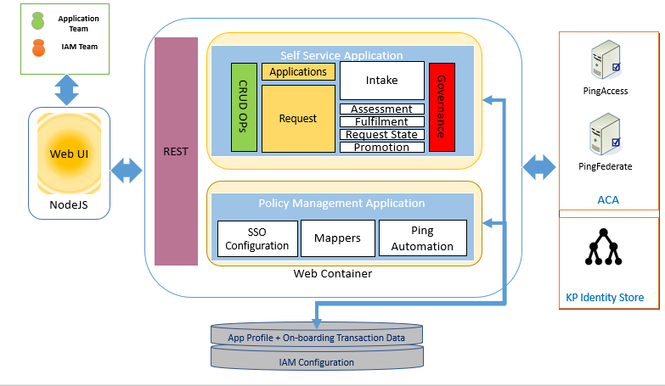

Figure 4: Logical Component Diagram

On-Demand Portal UI: User Interface of the On-Demand Portal. This will be developed using Single Page Application technology AngularJs, NodeJS and other packages related to rich look&feel, UI Widgets etc. User Interface will have screens with options for user to interact with to perform different functions.

Restful Interfaces: Services implemented by the backend component is exposed through set of Restful interfaces. Actions performed by the user through Web UI are performed by invoking these APIs

Policy Management Application: Framework developed by Persistent Systems to facilitate development of custom solution around use cases like self-service or policy management to any access management platform. The framework provides basic skeleton. Below are the modules of Policy Management Application:
- SSO Configuration component provides backend functionality to map inputs taken from user from different questionnaires to the entities corresponding to the integration model like SAML or OIDC/Oauth or PingAccess Gateway.
- Mappers component will understand SSO configuration details collected from integration questionnaire, configuration data files and other related details derived from application profile and will map these to PingFederate & PingAccess objects creation requests.
- Ping Automation component executers PingFederate and PingAccess API to create objects.

Self Service Application: Set of components that form a backend service required to support use cases of the On-Demand Portal. This layer consists of the data model, data access layer, Governance, behaviors like request state transition, promotions etc.

On-Demand Portal DB: Storage for holding application profiles, requests & their states, team contacts, automation artifacts and configuration.

PingAccess & PingFederate: Central Auth’s ACA consist of these two major platforms that provide Federated Access Management.

KP Identity Store: The ACA platform currently leverages the KP Datastore. Currently, Kaiser uses Active Directory and Enterprise Directory as the datastores. Datastores will supply attributes for either the IDP's attribute contract or SP's adapter contract.

: Application Module / Services Details

On-Demand Portal UI:
Once user is logged in to the portal, they will see dashboard page. The dashboard page will be the landing page. Below is the screen capture of the portal from the UI Wireframe Design:

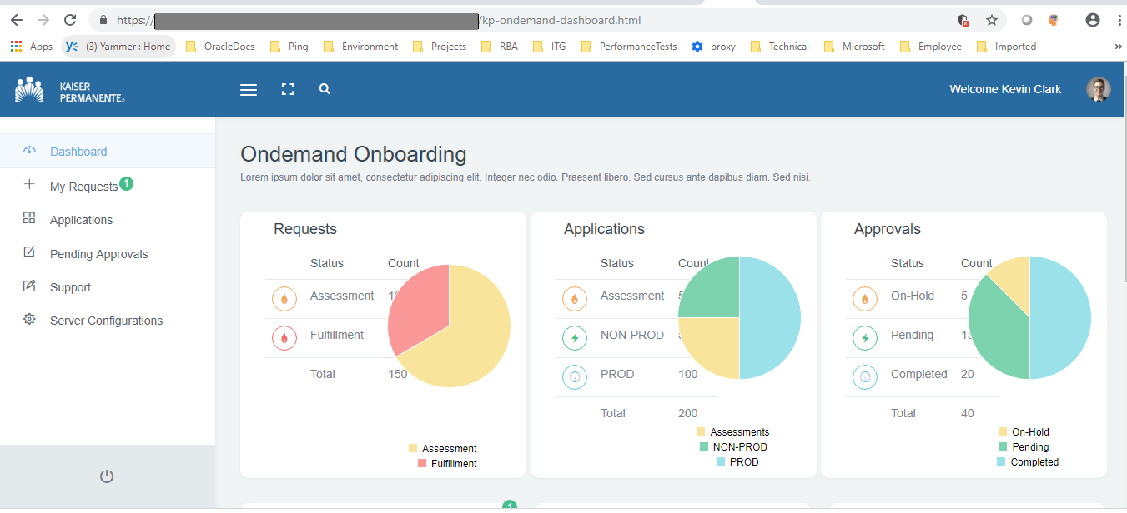

Below are the major user interactions that will be enabled by the Portal’s user interface. Screen captures of each of these interfaces and finer details can be referred in section User Interface Details :

View Dashboard
The Dashboard will consist of statistics for below type of entities
- On-boarding Requests
- Applications on-boarded or in the process of being on-boarded
- Approvals

On-boarding Requests | - Number of On-boarding Requests in Assessment stage/phase  - Number of On-boarding Requests in Fulfilment stage/phase
Applications | - Number of applications for which there are active On-boarding Requests that are in Assessment stage/phase  - Number of applications for which there are active On-boarding Requests that are in fulfillment phase and have been promoted to at least one Non-PROD environment  - Number of applications that have been promoted to PROD (including closed and requests are in warranty)
Approvals | - Number of On-boarding Requests that are pending for Assessment Agreement Approval  - Number of On-boarding Requests that are pending for Production Deployment Approval

View On-boarding Requests
There will two ways to get to the list of On-boarding requests.
- Both Application Team member and IAM Onboarding Team member can go to the “Applications” menu and search for the application they are interested in. For the application, they can view Associated Requests
- Application Team member can go to “My Requests” menu that will show all on-boarding requests where they are either requester or playing other in the on-boarding process Lile delegate for requester or business contact or technical contact or delegate for business contact.
- IAM Onboarding Team member can view all on-boarding requests in “My Request” screen

Raise new On-boarding Request
Both Application Team member or IAM Onboarding Team can raise new on-boarding request for the application. The “New Request” flow will facilitate application search. If the application is found, user can proceed to provide basic details of their request and then the request will progress through phases.

Refer section Logical Data Model for more on the request attributes.

Create/Update Application profile
Both Application Team member or IAM Onboarding Team can create/update profile for an application. The profile will consist of mandatory and optional attributes about the application.

Refer section Logical Data Model for more on the application profile attributes.

Create configuration in Non-PROD and PROD environments
IAM Onboarding Team will be able to create configuration in Non-PROD environment. User Interface will provide context menu for each onboarding request.

Configuration creation and provisioning will be based on the application lifecycles relevant for application.

Actions associated with On-boarding Requests
Users will be able to update request details like responding to different questionnaires, changing status of the request, creating/promoting configuration associated with the request to target IAM service.

Questionnaires
One of the core goal of the On-Demand Portal is to simplify the overall onboarding process right from the intake to fulfilment. User will progress the onboarding request in the portal by responding to set of questions or user input prompts. This section documents set of questions for different stages like Intake, Service Assessment, Solution Assessment.

Intake Questionnaire
Raising a new onboarding request consist of below steps:
- Select application to raise request for. If application does not exist, create one
- If application exist, update any attributes of application if required
- Provide basic details of the request

Attached document below captures intake questionnaire that consist of set of questions formulated to collect application profile attributes & request attributes from user.

Service Consultation Questionnaire
This questionnaire will be consisting of set of questions designed specifically to understand the security need of the business team for their application. Based on the responses Service Leader can identify exact service(s) that are must be configured for the application to meet security needs.

Refer links provided in the References section.

Solution Consultation Questionnaire
Once it is identified that applications need to be integrated with ACA service, as the ACA offers multiple integration models like SAML, OIDC/OAuth2.0 and PingAccess based Web Access Management, Service Leader will need to identify most suitable integration model. This questionnaire will be consisting of set of questions designed specifically to identify the integration module as well the decision if it is standard integration or custom.

Refer links provided in the References section.

Restful Interfaces:
On-Demand Portal User Interface will perform functionalities by invoking Restful APIs published by backend services layer of the portal. Attached excel workbook capture list of APIs that will be developed to support different functional flows and CRUD operations.
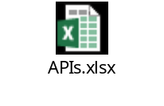

Integrations
This section captures design details to meet integration requirements.

Upload /Download Documents
On-Demand Portal UI will allow user to upload documents like email approval, any integration specific documents.

Below are the design specifics of this feature:
- Documents will be uploaded from user’s computer to the machine on which On-Demand Portal’s UI component is deployed. These documents will be saved on a files system of this machine under designated folder.
- Folder path under which documents will be stored can be configured.
- All documents will be identified by the on-boarding request identifier.
- Documents will be stored individually on the file system. Documents will not be compressed or will not be grouped together by any criteria.
- On-Demand portal will not
  - check and restrict Size of the document.
  - check and validate the content type of the document.
  - scan the document for any malicious content or any security threat.
  - support pushing these documents further to any other system
  - support backup & restoration of the documents uploaded through the portal
- Each uploaded document can be downloaded individually.
- All uploaded documents will be available for download to all those who can view onboarding request details.
- Portal will validate that user is logged in before allowing download of the document. This will be achieved by protecting On-Demand Portal using PingAccess.
- There will not be any coarse/fine grained authorization to allow/deny access to some documents. All documents will be accessible to every user who can view onboarding request details.
- While uploading documents, portal will allow user to select more than one files at once
- While uploading documents, portal will allow user to type brief description of the document
- Portal will display name of the uploaded and brief description as
- Upload will be based on the media-type multipart/form-data. Upload feature will be limited by any limitations of this media-type and its support in browsers or the underlying technical stack used for the development of On-Demand Portal.

Document Storage Details
Absolute path of the folder on the file system will be configured in On-Demand Portal’s configuration file.

Portal will create sub-folder under the document storage path where all uploaded documents associated with the onboarding request will be saved. Document file name will remain as uploaded by the user.

<Document Storage Path>/<on-boarding request id>_<application id>_<name of the file>

Folder and sub-folder will bear Linux permission “rwxr-x---” while files created under it will have permission “-rw-r-x---”

Email notifications
On-demand Portal will send email notification to required recipients to communicate the progress of the onboarding request when the request progresses to significant states. In cases where user’s need to take specific action, the email notification will provide such details.

Email feature will be developed using the existing utility source code developed by KPIM team. Email functionality will be limited in functionality and constrained by limitations or constraints of that utility code.

This design assumes that the email mechanism used will be the email mechanism implemented by the said utility. This design will not consider any other alternatives,

On-Demand Portal will not support general email functionality. All notifications will be generated by the system internally.

Notification Events
Email based notification will be sent by the portal automatically for below events:
- New Onboarding Request is registered
- Service Assessment Questionnaire has been responded 100% by the requester
- Service Assessment Agreement & Report has been generated by the Service Leader
- If recommended service is ACA, Service Assessment Agreement & Report has been approved by the Business Contact
- Service Leader’s recommendation on Standard/Custom ACA onboarding
- IAM Integration Team have created configuration in Non-PROD environment
- ASG Operation Team have initiated promotion to PROD
- Promotion to prod has been approved by Business Contact
- Promotion to prod has been approved by ASG operations team
- Configuration has been promoted to PROD
- IAM Onboarding Team has closed the request
- Request has been put on hold

Email Notification Format
Field | Details
From address | iamportal@kp.org
Subject | <Application Name> Onboarding Status - <Notification Event type as enumerated above>
Body | Common text-based template for all notifications.  The on-boarding request for application <application name> tracked through request id <on-boarding request id> has progressed to <current state>.  Action Required: <Action required value will be based on the request state>  Action Required By: <Email address of the contact responsible to take said action>  Please contact below members from IAM Department for any specific query:  <Name> , <Responsibility>  Notice: This is auto-generated email. Please do not reply to this email.
Email format | Text
Attachment | Not supported

Email Service Configuration
Configuration | Details
KP SMTP Server host | DNS hostname of KP SMTP Email Server
KP SMTP Server port | TLS port used by KP SMTP Email Server
Service Account | Required if KP SMTP Email Server requires authentication
Trust certificate of KP SMTP Email Server | Trusted CA certificate chain of the issuer of the certificate used by KP SMTP email server
Connectivity to KP Email server | It is assumed that KP Email Server connection can be established from the environment where On-Demand portal will be deployed.

ServiceNow request for custom onboard and CRQ
On-Demand Portal will support automated integration of application with Advanced Central Authentication platform from Central Auth Service. Integration with other IAM services will still be fulfilled manually. Even for ACA, if application requires specific features of integration that portal does not support, the integration will be considered as custom.

Today, there is a well-defined manual process to onboard application to any of the IAM services. The initiating point is to raise something called as Work Order in the ITSM system.

This design assumes the reuse of the utility code developed by KPIM team that can create request in ServiceNow. However, the request that it creates in ServiceNow and the Work Order as it is known today in the manual process, may not be the same.

It is beyond the scope of this design create anything that is equivalent to Work Order process being followed in the system.

Portal will support integration with ServiceNow for the purpose initiating manual on-board or to raise the Production Promotion CRQ only if both these are same as raising plain request in ServiceNow as supported by thee KPIM utility code.

In case there are gaps in in fulfilling above pre-requisites, this feature will not be supported by this design and this version of the portal.

IAM Automation
This section captures standard set of configurations for each in-scope integration models like SAML, OIDC/OAuth2.0 and PingAccess Site.

Depending on the type of the ACA standard integration model chosen for the application, different artifacts need to be created through the On-Demand Portal. To achieve successful creation of these artifact, some inputs will be prompted from the user, some information will be treated as static configuration at the portal side and some pre-requisites will have to be met ACA beforehand. The details below elaborate the dependencies for each integration model:

Validations
- Validations of mandatory values that are expected from user. These validations will be handled at the user interface level
- Automation will perform below validations
  - SAML SP ACS URL or Oauth2.0 redirect URL must be https.

OAUTH2.0
Artifact to be created through automation is OAuth Client.
- Configuration at Portal:
  - Access Token Manager (ATM) will be pre-created with standard set of attributes and will be mapped to authentication policy contract. The id of the ATM will be configurable at the portal.
- All other inputs required for OAuth Client creation will be taken from the user which may include selection from a pre-set list of attributes, scopes, allowed grant types etc.

OpenID Connect (OIDC)
Artifact to be created through automation is OAuth Client with OIDC Policy.
- Configuration at portal:
  - Same requirement for ATM as discussed in OAUTH2.0 section above.
  - OIDC Policy pre-created at PingFederate. Id of this policy will be configurable at the portal.
- All other inputs required for OAuth Client creation will be taken from the user which may include selection from a pre-set list of attributes, scopes, allowed grant types, signing algorithms etc.

SAML2.0
Artifact to be created through automation is SAML SP Connection.
- Configuration at portal:
  - Id of the data store. This will always be the “CSAD” datastore, which points to KP Active Directory.
  - Name of the custom user object class used at KP Active Directory.
  - Attributes of custom user object class used at KP Active Directory. These attributes will be available for the user to select from to define attribute contract for the SAML SP connection to be created.
  - Known cert key pair that will be used by PingFederate to sign the assertion
  - Most other SAML2.0 protocol specific granular details will be assumed fixed values in configuration.
- User will provide details like entityID, attribute list from the preset list etc. basic protocol specific inputs.

PingAccess Gateway
Portal shall only support creation of PingAccess application configured with PingAccess site-based configuration, which is also known as Gateway or Proxy.

Artifacts to be created through automation are:
- Virtual Host
- Identity Mapping
- Application
- Resource
- Web Session
- Site
- Application specific Oauth2.0 client that will be referred from Web Session.

PingAccess automation will not support creating authorization rules. Most other features like Availability Profile, Load Balancing Strategy etc. will be PingAccess default values.

- Configuration at portal:
  - Default values for different parameters like name of the PA cookie, Web session parameters, properties of a Site etc. will be fixed configuration.
- User will provide inputs like application context root, attributes expected by the application through Identity Mapping etc.

Attached document “Integration Questionnaire” list technical questions that will be promoted to user for different integration models. Other attached documents capture further finer details for each integration model.

Few important points noted in these worksheets:
- OAuth clients and SP connections will be bound to KP_DEFAULT_CONTRACT. This will be configurable at portal and needs to be provided by Kaiser.
- OIDC Policy to be associated with OAuth Client for OpenID Connect will be configured at portal and needs to be provided by Kaiser.
- OAuth client secret - Design assumes that client secret will have to be changed in Ping Federate console by IAM Integration team for Non-Prod and Ops team for PROD, to share it with application team. Portal will either use fixed value for secret or randomly generated secure string, but it will not store it in DB or display it on UI.
- Ping Access site will always have application specific web session and OAuth client.

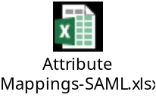

PingAccess & PingFederate:
PingAccess and PingFederate will need to be configured in certain way to support automate creation of standard configuration for each of the in-scope integration models. This section will capture those details.

The details below elaborate the standard configuration needed for each integration model:

OAUTH2.0
Pre-requisite configuration at Ping Federate:
  - Access Token Managers – 2
    - Basic - 5 attributes
    - Advanced - 10 attributes
  - Authentication Policy Contract Mapping
    - USER_KEY & USER_NAME should be mapped to Authentication Policy Contract attributes
  - Access Token Mapping
    - Map Access Token Managers created in (a) with Authentication Policy Contract Mapping created in (b)
    - Map the Contract Fulfillment of attributes from Access Token Manager to attributes from Authentication Policy Contract Mapping or LDAP
    - Associate authentication policy contract to appropriate authentication policy.
  - Create pre-defined scopes to be supported

OpenID Connect (OIDC)
Pre-requisite configuration at Ping Federate:
  - Access Token Managers – 2
    - Basic - 5 attributes
    - Advanced - 10 attributes
  - Authentication Policy Contract Mapping
    - USER_KEY & USER_NAME should be mapped to Authentication Policy Contract attributes
  - Access Token Mapping
    - Map Access Token Managers created in (a) with Authentication Policy Contract Mapping created in (b)
    - Map the Contract Fulfillment of attributes from Access Token Manager to attributes from Authentication Policy Contract Mapping or LDAP
    - Associate authentication policy contract to appropriate authentication policy.
  - Create pre-defined scopes to be supported
  - OIDC Policies – 2
    - Basic – 5 attributes
    - Advanced – 10 attributes

SAML2.0
Pre-requisite configuration at Ping Federate
  - KP_Default_Contract will be used in every SP connection created by the portal. For additional attributes, SP connection will be created with attribute source based on CSAD KP Active Directory Data Store.
  - Authentication Policy attached to KP_Default_Contract will be enforced for every SP Connection created by the portal.

Ping Access Gateway
Pre-requisite configuration at Ping Access and Ping Federate
  - PingAccess and PingFederate must be property integrated where PingFederate is configured as Token Issuer.
  - Same configuration as discussed above in OIDC section.
  - Default Engine Listener, which runs on port 3000 will be used.
  - PingAccess must be configured to be able to trust certificates from Target Servers behind the site. Alternatively, Portal can create site to trust any certificate.

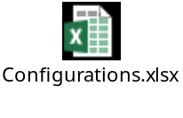

Promotion

Promotion to PROD
On-Demand Portal will also initiation of promotion to PROD (Prepare for promotion to PROD), only if below criteria is met:
- Configuration has been created to the designated mandatory non-prod environment
- Only designated ASG operations team member will be allowed to initiate promotion to prod.
- By process it is understood that ASG Operations team has raised CRQ and performed all the activities that are defined for PROD promotion. These activities include seeking CRQ approvals, taking backup etc. On-Demand portal will not enforce these validations or will not perform these pre-requisite activities.

The process of preparing for promotion to PROD will consist of 2 level approvals that will happen in sequence, where business contact will approve it first and then ASG Operations team will approve it.

Only after the 2-level promotion, only ASG operations team will be able to trigger actual promotion. Portal will prompt user to enter approved CRQ number. Portal will validate the value entered as CRQ number is as a valid CRQ number. The validation will be limited to verifying that CRQ number is per the expected format.

Application Module Configuration Details
Covered in previous section.

Vendor Application Gaps / Customizations
Not applicable

User Interface Details
OnDemand Portal- My Requests
User will see screen with list of all request owned by the user. The listing will show current stage as well as the deployment status.

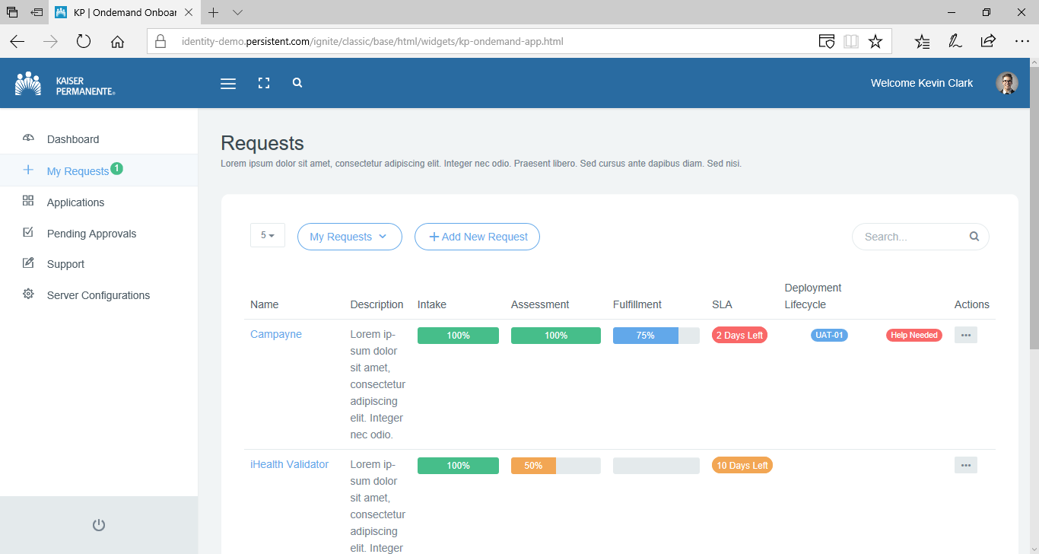

OnDemand Portal- Add New Request

User can initiate new onboarding request by clicking “Add New request” button.
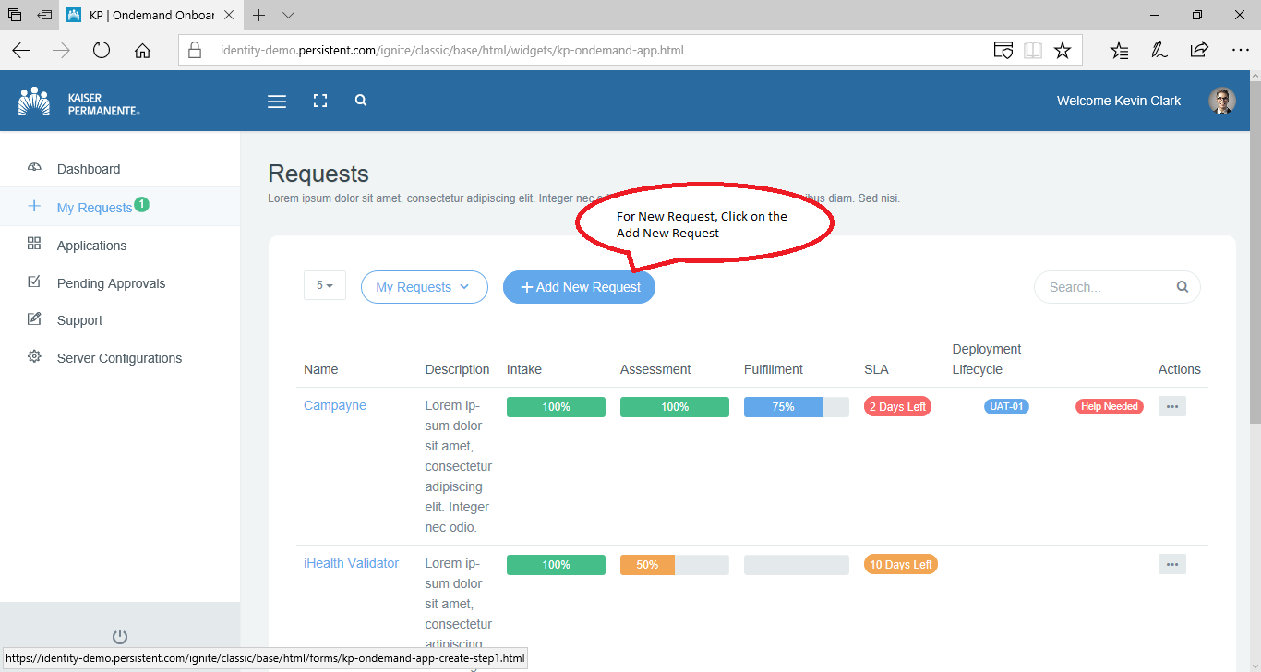

User will key-in Application name, portal will automatically search for application profile in its database. If found populate all form fields.
If application profile is not found, user will first create application profile by providing application details.
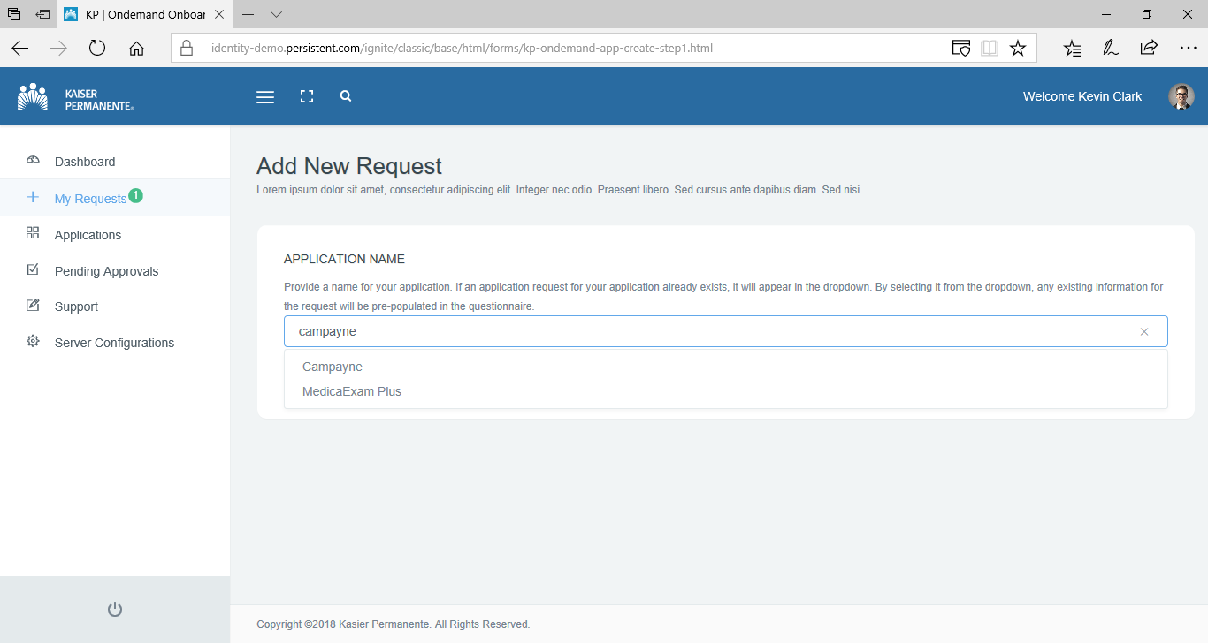

If application is found, user will be prompted for questions to know basic details of their request.
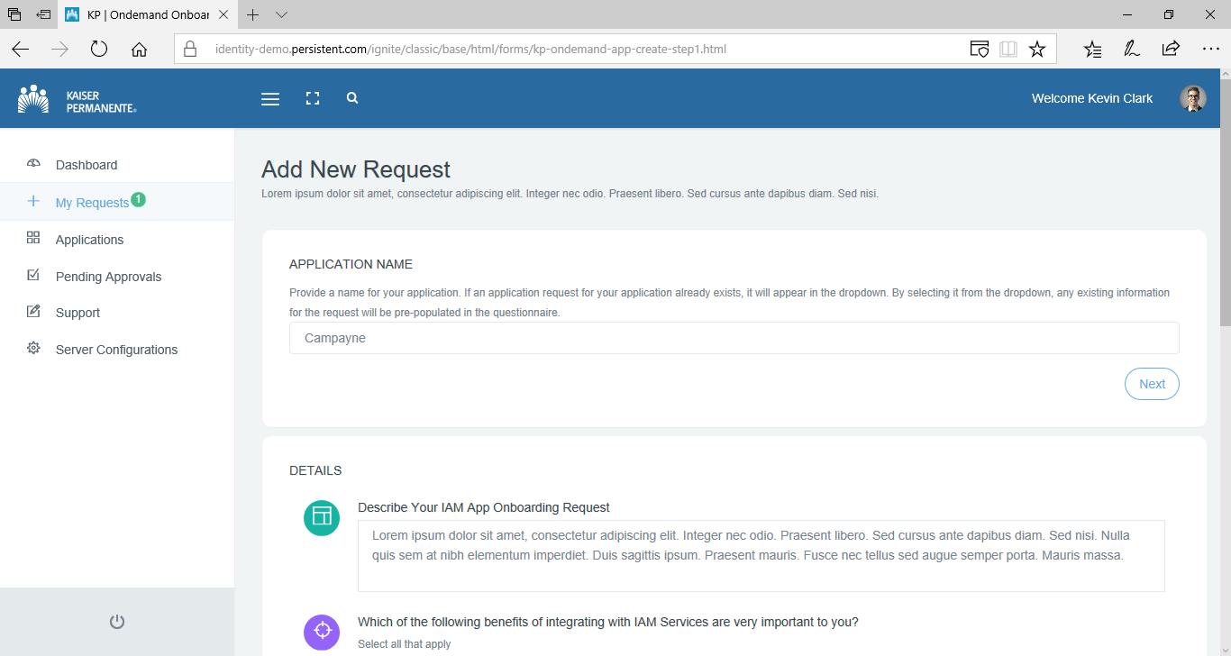

OnDemand Portal- Edit Request Details
User can view and Edit their onboarding requests. The context of the edit operation depends on the current state of the request.

Edit operation could be used to:
- Respond to Service Consultation Questionnaire
- Respond to Solution Consultation Questionnaire
- Respond to Fulfilment Interview Questionnaire
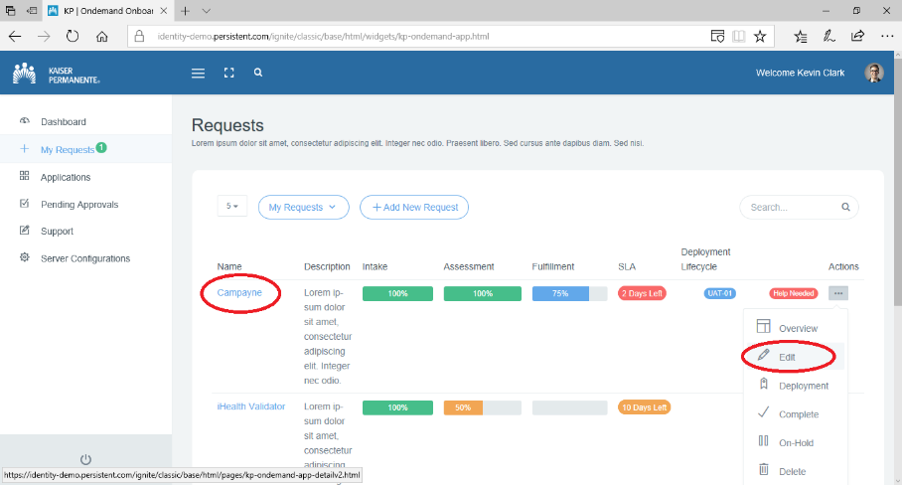

User can use the Edit option from the dropdown at the right side under the actions column.

User can navigate to the detailed view of the request by click on the Request ID or Application Name column. Below screen shows the detailed view of the selected request.

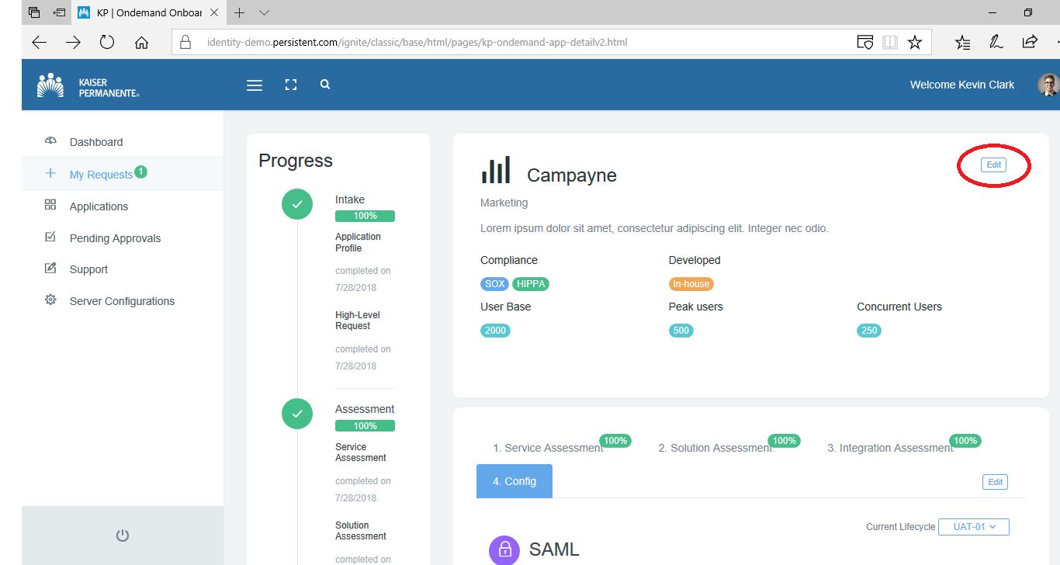

Below screen show edit “Application Profile” launched from Request Details View.
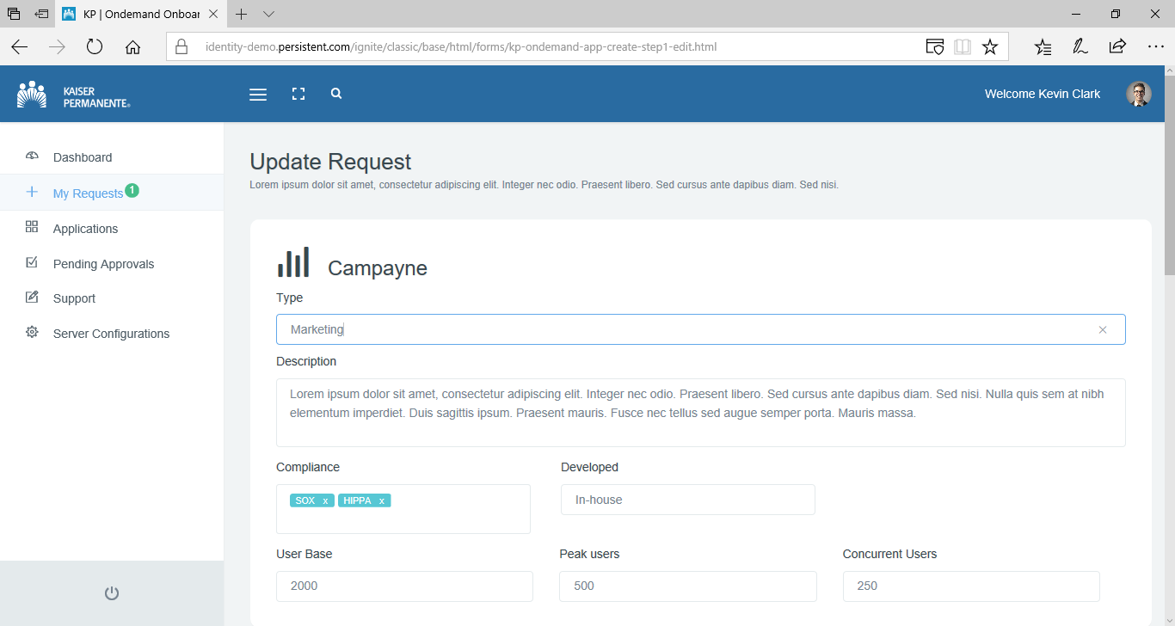

Request details or questionnaires will be displayed like below in the edit view. User can use “Save as Draft” to save their edits.
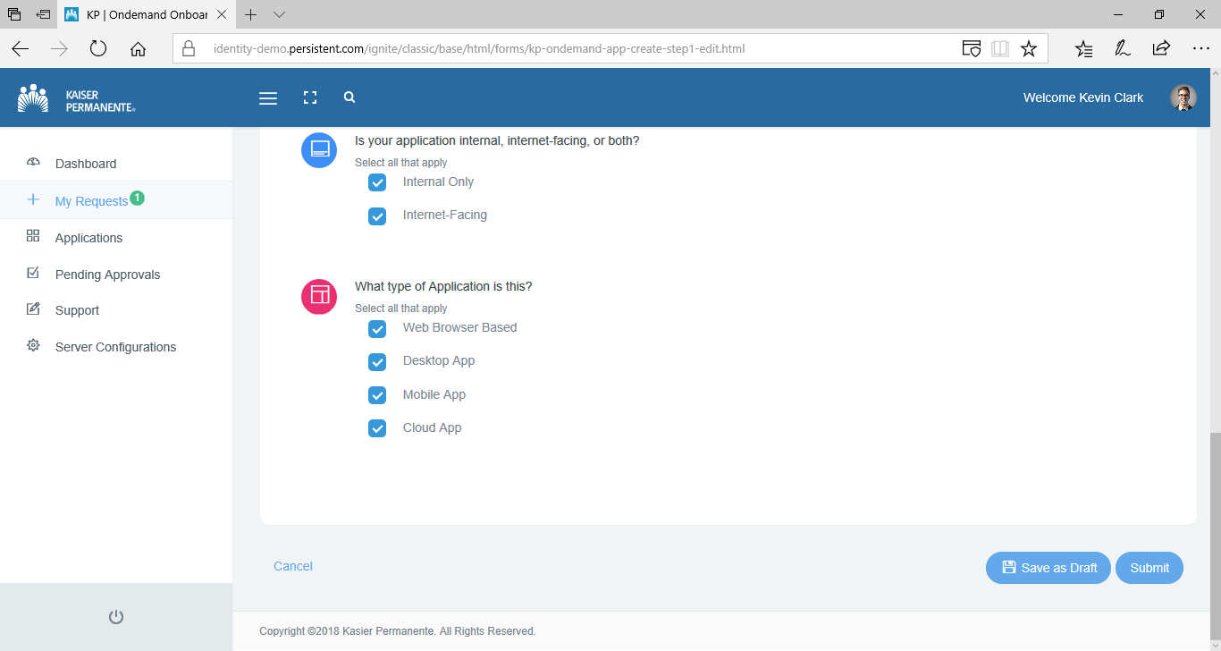

OnDemand Portal- Request Overview

Using the ‘Overview’ option user can check the basics details of the onboarding request.
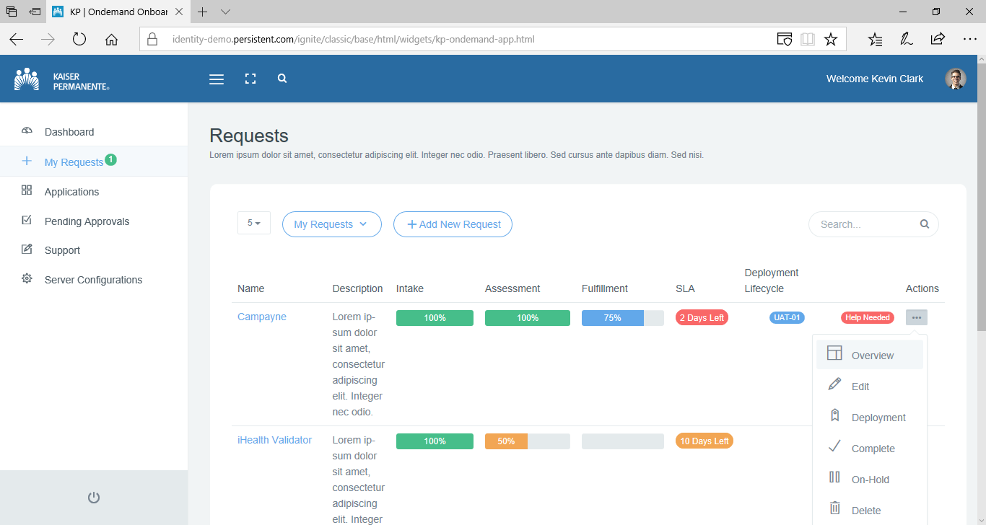

If selected onboarding request is in fulfilment stage, the overview screen will also show the configuration created for the application.
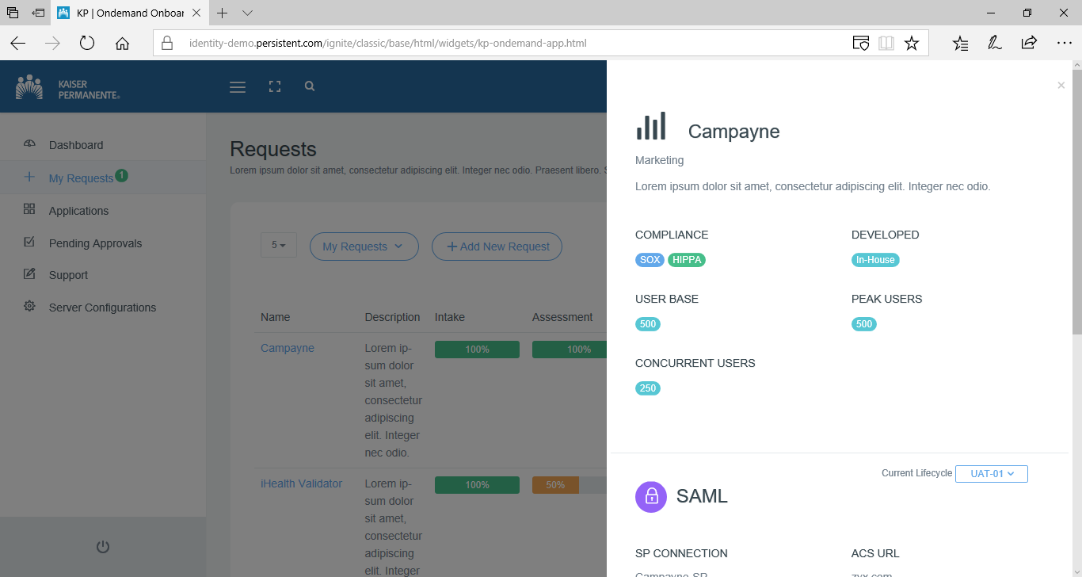

OnDemand Portal- Configuration Deployment

- User will be able to provision authentication configuration to ACA Non-Prod environment for application’s lifecycle (DEV, QA, UAT etc.)
- User will be able to provision authentication configuration to ACA PROD only if configuration has been promoted to designated Non-PROD-MUST environment (for example, UAT).
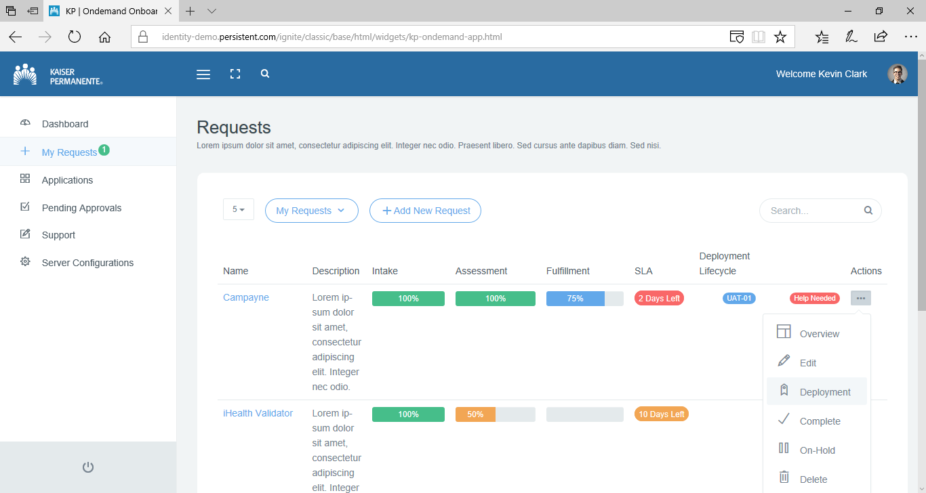

Below screen allow user to choose the next application lifecycle for which configuration will be promoted in IAM environment.
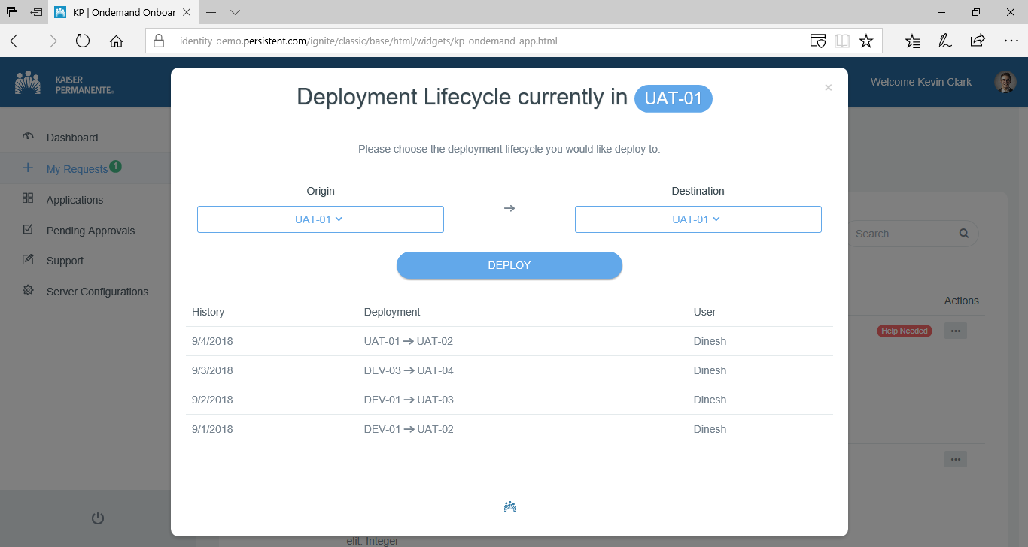

OnDemand Portal- Onboarding Request State Transition
User can check the current state of their onboarding requests. Request could be in Intake, Assessment, fulfillment stage. If the request is in Fulfilment stage, they get to see the exact lifecycle that has been configured in ACA.

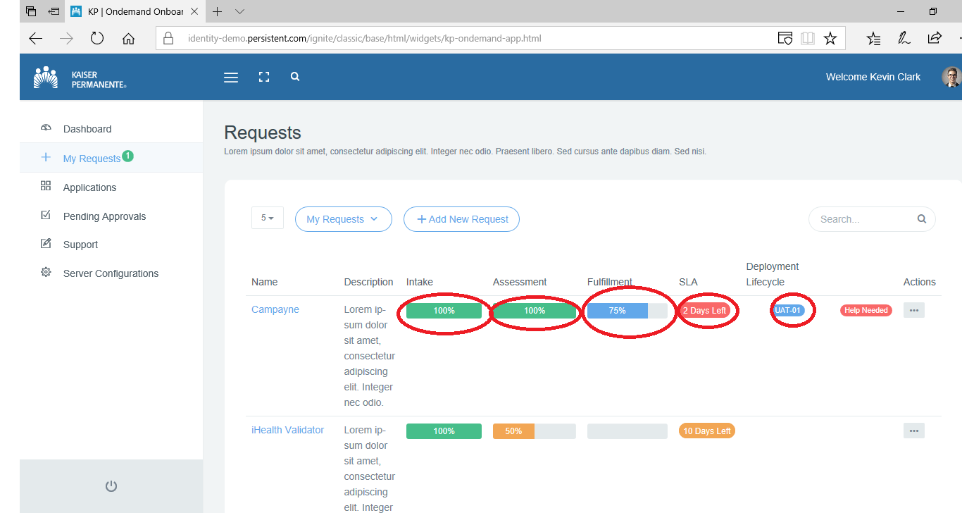

Below screen shows that onboarding request has progressed beyond Intake stage.
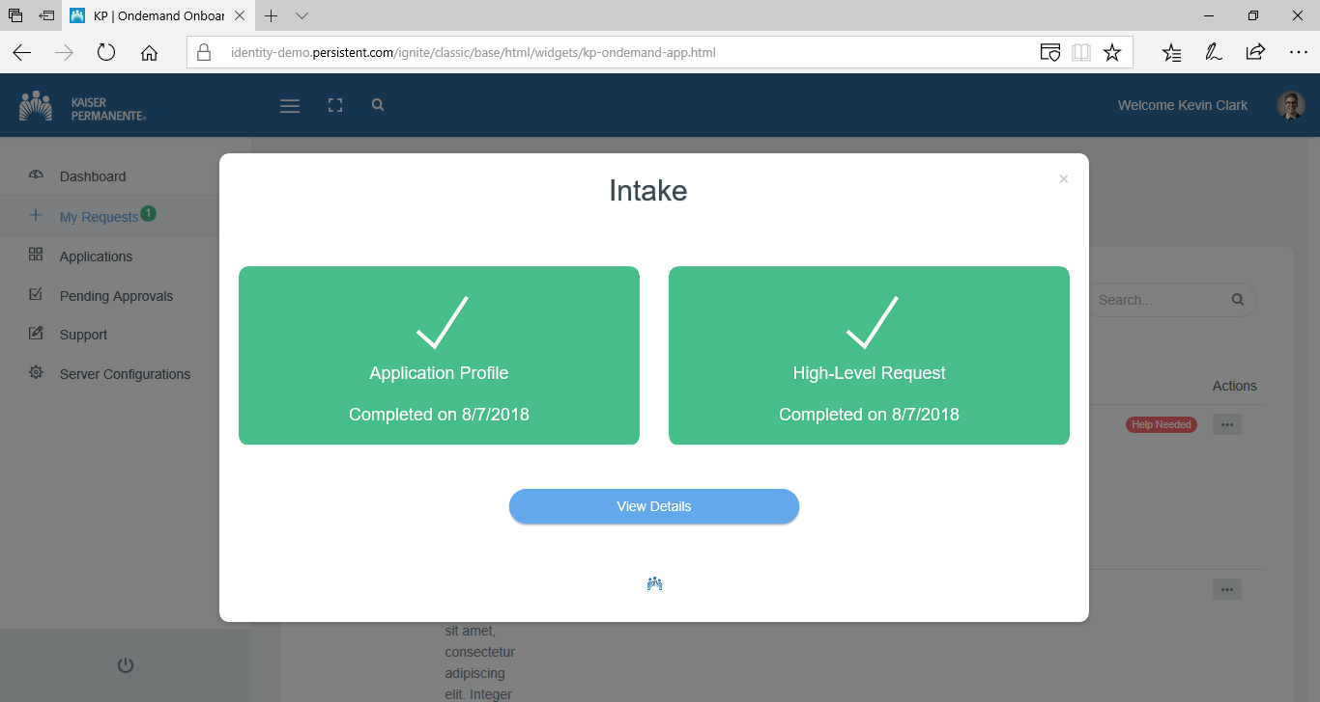

Below screen shows that onboarding request has progressed beyond Assessment stage.
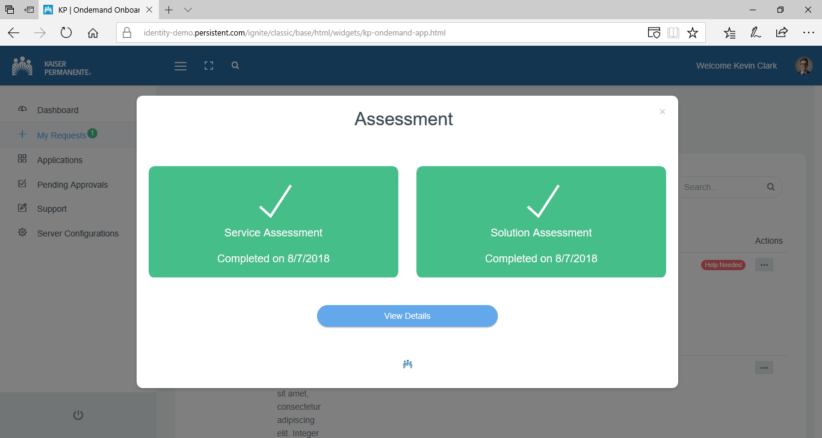
Below screen shows that onboarding request is currently in Fulfilment stage where the configuration creation in application lifecycle environment and pending for validation. It also shows next stages.
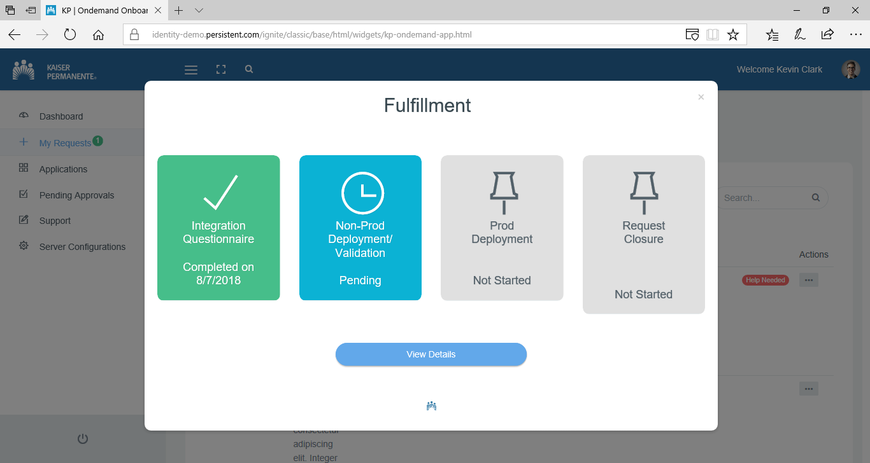
OnDemand Portal- View and Edit Application Profiles
Users can get to Applications listing by clicking “Applications” tab.
- If a user in Application Team member, he could see only his own Applications.
- If a user is from IAM On Boarding team, he could see Applications of across all Users.
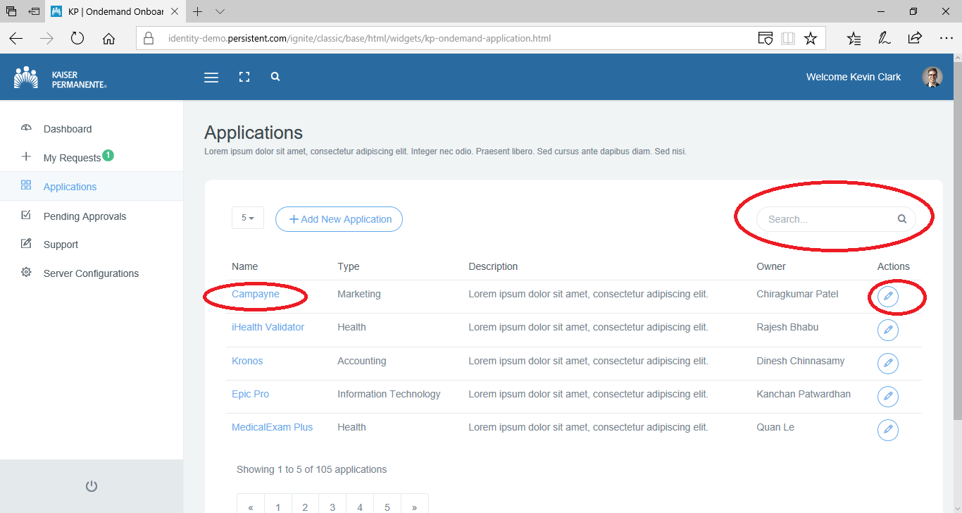

Application profile could be searched using Search. If matching application is found, user can view application profile details, either he can click on the Application Name or Action Button of the respective Application record. User also can edit the application profile part, irrespective of the status of the requests associated with it. As all required information would be already set when the application profile was created, only optional fields that were left blank could be edited. No other information that is already set could be changed.
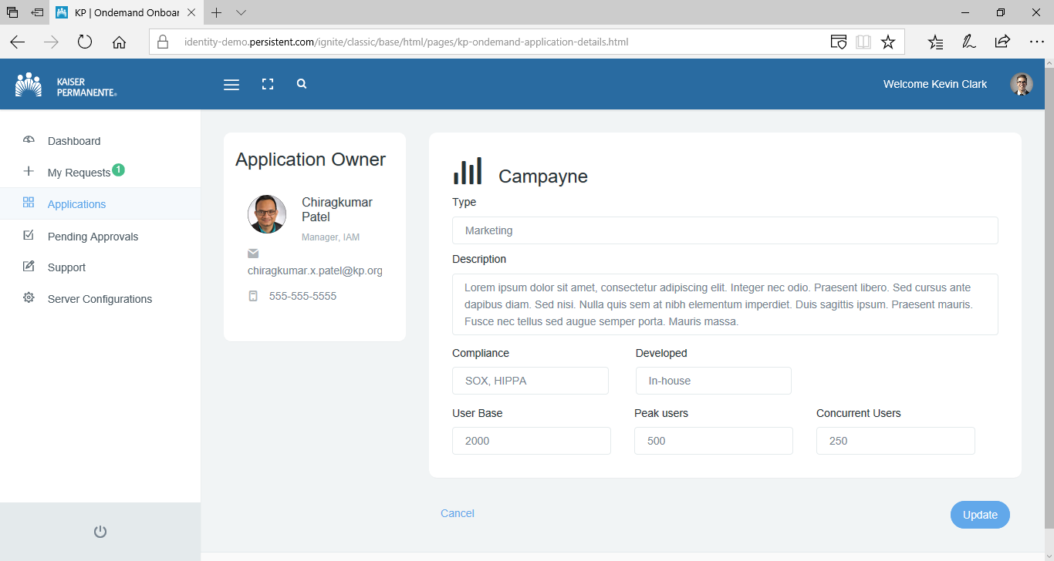

OnDemand Portal- Pending Approvals:
User will be able to review and approve assessment and recommendation.

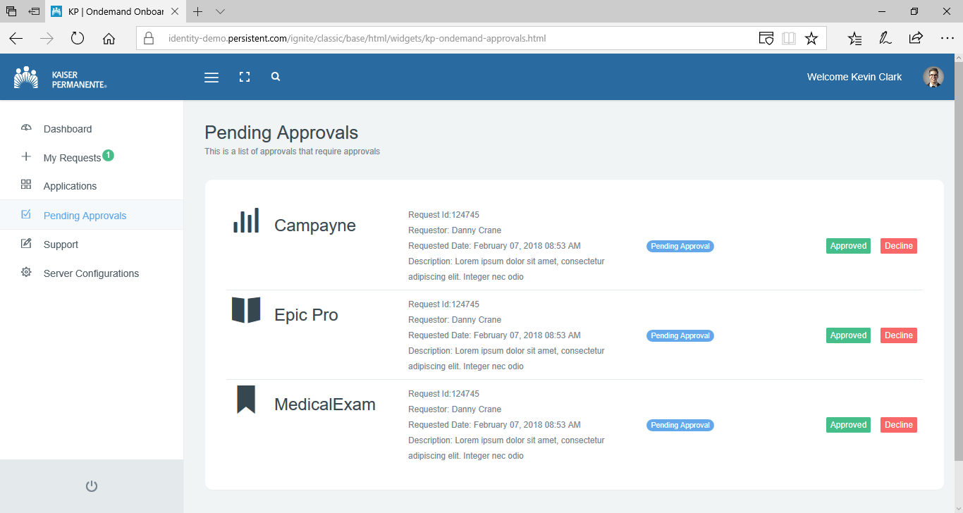

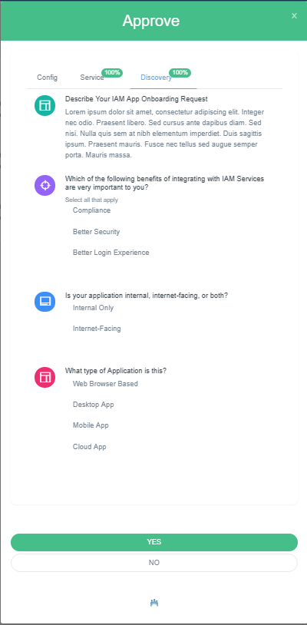

OnDemand Portal- Server Configurations:
Administrator of the portal will be able to provide system configuration details as part of the one-time initial setup of the portal.
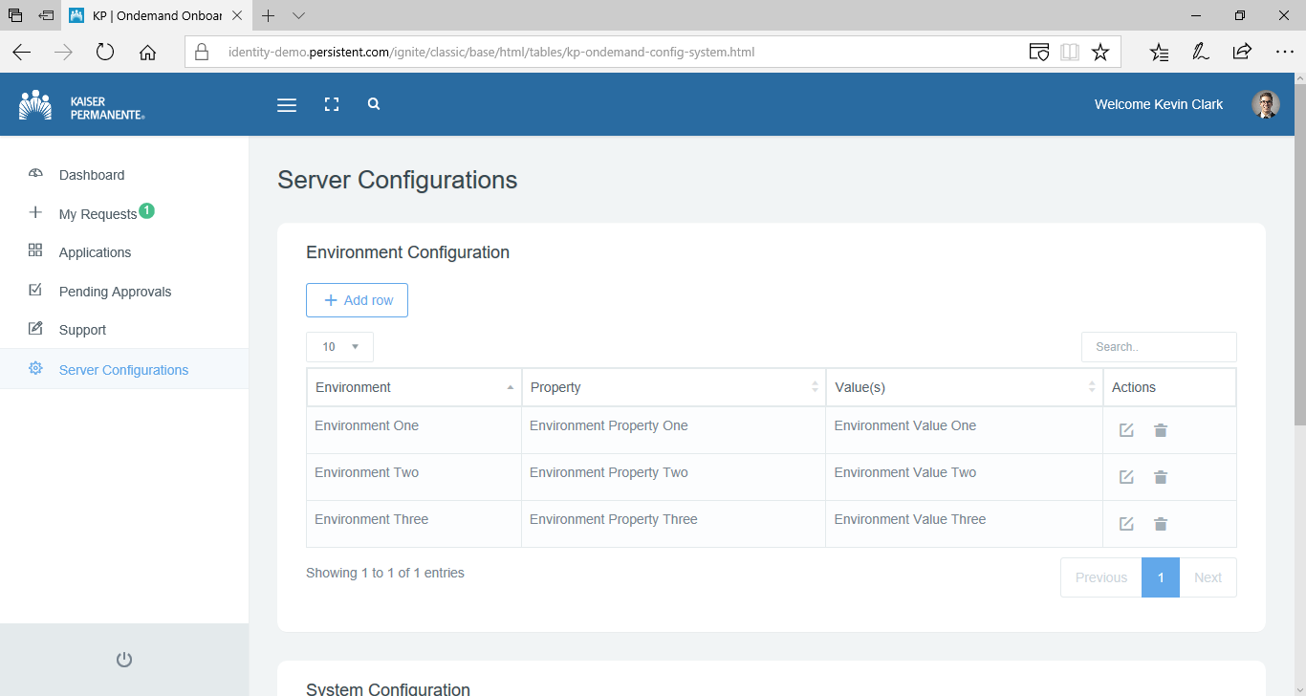

Component Realizations

<< Insert Realization Title >> Sequence Diagram
Skipped as flow diagram covers this.

Security

Authentication
Below table provides details of the authentication to On-Demand Portal as well as specific requirements from PingAccess and PingFederate.

Scenario | Behavior | Requirements from  Ping Access and Ping Federate
Login | - User access On-Demand Portal’s URL, which is a GTM served URL and GTM in turn will route the request through PingAccess site  - PingAccess will redirect to PingFederate for authentication.  - Depending on Ping Federate’s configuration, user will be authenticated using configured authentication mechanism. This design recommends use of Kerberos Authentication without MFA  - Upon successful authentication PingFederate will redirect back to PingAccess. PingAccess site will route request to On-Demand Portal’s Target Host.  - On-Demand Portal will obtain Request Header provided by PingAccess to identify the user. It will also obtain the ID Token provided by PingAccess.  - On-Demand Portal will set its own session.  - On-Demand Portal will identify if user belong to IAM department based on the claim in ID Token. | - Create OAuth2.0 client in Ping Federate for On-Demand Portal with below details:  - Return URL as https://ondemandiam.kp.org/ondemand/callback  - ID token settings such that it contains claim indicating that user belong to IAM org  - Bypass consent  - Client id as ‘ondemand-iam-client’  - Client authentication mechanism as ‘Client Secret’  - Set value for client secret  - Configure PingFederate to enforce Kerberos authentication mechanism and not enforce MFA.  Note: As On-Demand Portal does not contain any sensitive data, MFA is not required.  - Create Web Session in Ping Access with below configuration:  - Name as ‘ondemand-iam-web-session’  - Cookie type as ‘Signed JWT’  - OpenID connect login type as ‘Code’  - Client id and Client secret as the Client id (ondemand-iam-client) and client secret created in the step above in Ping Federate.  - Create two Virtual Host in Ping Access with below configuration:  - Host as ‘ondemandiam.kp.org’  - One with port as ‘8080’ and other with port as ‘443’  - Create Site in PingAccess with below configuration:  - Name as ‘ondemand-iam-site’  - Targets as ‘https://prod-troiam-webui-ondemandportal-1.TROIAM.int-svc-bmxp-sj.appl.kp.org:443’, ‘  https://prod-troiam-webui-ondemandportal-2.TROIAM.int-svc-bmxp-sj.appl.kp.org:443’‘, https://prod-troiam-webui-ondemandportal-1.TROIAM.int-svc-bmxp-dal.appl.kp.org:443’, ‘https://prod-troiam-webui-ondemandportal-2.TROIAM.int-svc-bmxp-dal.appl.kp.org:443’ (Host name are subject to change during the course. Actual host names to be obtained from Bluemix deployment plan)  - Select Secure as ‘Yes’  - Create Application in Ping Access with below configuration:  - Name as ‘ondemand-iam’  - Context root as ‘/iamportal’  - Virtual Hosts as created in Step 4.  - Application Type as ‘Web’  - Web Session as the one created in Step 3 with name ‘ondemand-iam-web-session’  - Destination as Site with name as the one created in Step 5 as ‘ondemand-iam-site’  - Resources as ‘/*’  - Create Identity Mapping of type Request Header to send NUID, Display Name attributes of logged in user
Logout | - User clicks “Log out” link  - On-Demand portal will redirect on fam logout URL | None

Access Control
Based on the claims in the OIDC ID Token, portal will identify if the logged-in user belongs to IAM organization. Accordingly, it will render the content and user interface features.

Below are the different teams and roles:

Team | Role
Application Team  On-boarding request will capture contacts from application team that will play these roles. | Requester
 | Requester Delegate
 | Technical
 | Business Contact
 | Business Delegate
IAM Onboarding Team  Every on-boarding request will automatically get Service Leader Team members, Integration Team members and Operations team members assigned. Details of these members from IAM Department will be available to the portal through its configuration. | Service Leader
 | Integrator
 | operations

Below workbook capture above stated roles and their privileged. On-Demand Portal will restrict/allow activities based on these role-privilege mapping.


Volume & Performance Metrics
There are not any performance targets defined for the portal. Portal is going to be used mainly by the IAM On-boarding team and few users from application teams. At any given point in time, there will not large number of users using the portal.

Information Availability and Disaster Recovery

Availability and DR Process Detail
Current plan is to deploy On-Demand Portal on IBM Cloud.
On-Demand Porta Disaster Recovery Class of Service is 4.
Portal is not used by all end users of Kaiser Permanente. It will only be used by handful of people from the business whenever their applications are getting on-boarded and IAM on-boarding team. Thus, portal does not need to be highly available or even hot standby.

However, as the solution will be ultimately deployed on IBM Cloud, it should be easy to create a DR setup on need basis. This will be handled by IAM Infrastructure & Engineering Team by coordinating this effort with Kaiser Permanente’s IBM Cloud Team.

Logical Data Model

Logical Data Model – Database Design
The database design cover design of below listed entities & sub entities and relationship among them.

Application Profile
  - Will consist of set of primary attributes of the application which are used to clearly identify the application, its owner and understand its business purpose
  - Kp_application_profile will have id which will be auto-increment number that will be generated through database level sequencer. This id will be used to link entities.
  - Kp_application_profile will also have application id which will be of the form <app short name>_<16 characters GUID >. This identifier will be used only for the display purpose.
  - Application id will be Extensible design to accommodate more granular information about the application. The design makes it possible to map additional attributes from the Asset and Inventory Management platform like ATLAS in case of KP.
  - ‘kp_application_profile’ primary attributes about the application while kp_application_profile_attributes sub entity will hold more granular information about the application through extensible list of attribute-value pairs.
  - kp_application_lifecycle sub entity will hold information about application’s different lifecycles like DEV, QA, UAT, PROD etc. Lifecycles will not be fixed set for each application. If application maintains more than one environment for any of the lifecycle, the lifecycle will be derived using the lifecycle name and the environment number. For ex. DEV1, DEV2, QA1, QA2 etc.
  - kp_application_lifecycle will also hold information about the given lifecycle
    - Number that defines its’s order in the lower to higher chain
    - Flag that indicates if the configuration creation will start from this lifecycle. Only one lifecycle can have this flag set
    - Flag that indicates if the configuration must be created/promoted for this lifecycle. One or more lifecycle can have this flag set.
    - Flag that indicates if the configuration must be created/promoted to this lifecycle before promotion to prod. Only one lifecycle can have this flag set.
  - kp_application_lifecycle_attributes sub entity will hold connection details of application for the given lifecycle. For example, application’s base URL.

Onboarding Request
  - Request entity will consist of set primary attributes of the request like id, application id, creation date, closure date, reference to IAM configuration.
  - Kp_request entity will have id which will be auto-increment number that will be generated through database level sequencer.
  - Kp_request entity will also have request id, which will be <16 char GUID>. This will be used only as display value.
  - Request entity will refer to other sub entities that hold details like
    - Application Team and IAM Team contacts associated with the request & their role
    - Extensible sub entity to hold additional attributes about the request. This will also hold responses to different questionnaires.
    - Provisioning/promotion status of the request
    - Static definition of different states through which on-boarding request will pass
  - Kp_request entity will hold primary attributes of onboarding request
  - Kp_request_attributes will hold additional attributes of on-boarding request. For example, user’s responses to questionnaire will be stored in this entity
- Onboarding Request state definition & transition
  - Kp_request_states_definition holds static data about the different states and their grouping. This information will be presented on the user interface so provide exact state of onboarding request
  - Kp_request_states will provide state of onboarding request at any given point. This use request state definition from the kp_request_states_definition entity
- Onboarding team contacts
  - Kp_request_contacts will hold reference to kp_request and kp_contacts entity such that it can provide all team members that are associated with the request along with their email and phone number
- Onboarding request action ownership
  - Kp_request_contacts entity will hold role of the user. Portal shall make use of this information to implement basic governance to restrict content display to user and to involve sub set of users in flow like assessment approval or provisioning approval.
- Application to Request association
  - Kp_request will have reference back to kp_application_profile entity. This will enable Portal to find all associated requests for a given application
- Provisioning progress for each application lifecycle
  - Kp_request_provision_status sub entity will track the provision/promotion of the configuration for different lifecycle/environments of application. This entity refers to its parent entity, which is kp_request
  - It also holds details about the approval status required for the provisioning/promotion
- IAM Artifacts
  - There will be multiple sub entities to hold data required to create IAM artifacts for the chosen integration model (SAML, OIDC/OAuth2.0 or PingAccess Site). As most of this is part of Persistent System’s Policy Management Tool (PMT) framework, this document does not cover these in detail
  - ‘oauth_client’ entity and its sub entities will hold all data required to create OIDC/OAuth2.0 related artifacts
  - ‘provider’ entity and its sub entities will hold all data required to create SAML SP connection
  - ‘application’ and its sub entities will hold all data required to create PingAccess Site (also called as Gateway or Proxy) artifacts
- Request to IAM Artifacts association
  - Kp_request entity will hold type of the integration model and the reference to corresponding IAM artifact related entities like ‘oauth_client’ or ‘provider’ or ‘application’.

Figure 5: Entity Relationship Diagram
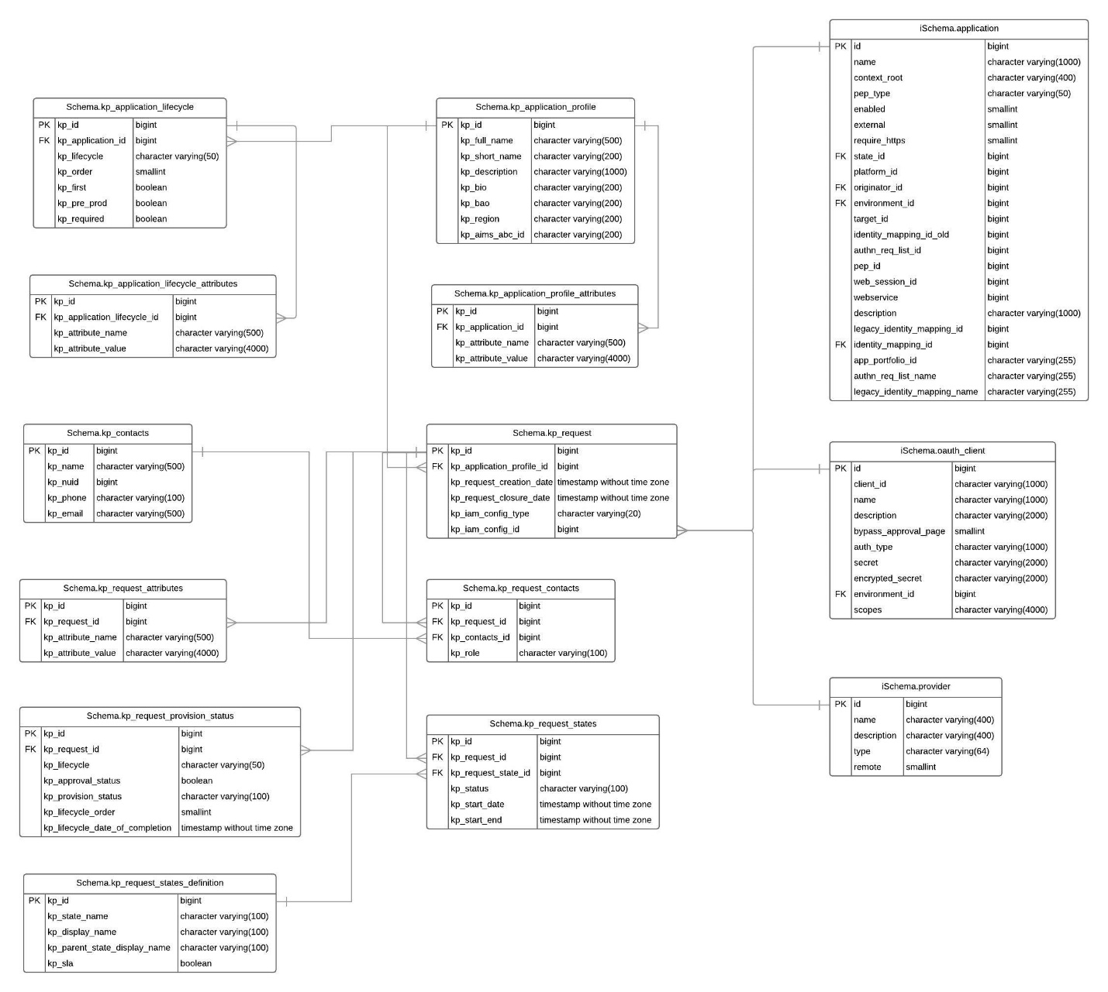

Sensitive Data Summary
On-Demand Portal will not store any PHI (Patient Health Information), PCI data or any other sensitive data apart from below listed Personally Identifiable Information:
- Email
- Contact number
This information will be used by the portal to send email notifications. User logged in to the portal might need to know the contact details of the team involved so that they can contact them for any specific ask about the on-boarding request.
On-Demand Portal will maintain below sensitive access details about the external system:
- Service account name and password for PingAccess
- Service account name and password for PingFederate
- Service account name and password for KP Identity Store, which is Active Directory
These service account details will be encrypted with password-based encryption scheme.

Data Lifecycle and Retention Considerations
Not applicable.

Solution Physical Design
On-Demand Portal solution contains three components, which are, user interface, backend services and database. User Interface is a standalone application that runs in NodeJS environment. Backend service layer is a J2EE application that can be deployed on containers like Tomcat or JBoss.

While the solution is being developed to be deployed on set of Linux machines, current plan is to deploy it on IBM Cloud.

One of the core requirement of the portal is to automatically create configuration at ACA platform. Portal will communicate with components of ACA to create integration configuration for application being onboarded.

Disaster Recovery site could be created by replicating the nodes that hosts components of On-Demand Portal.

This solution will be accessible from within KP intranet only. Solution will be accessed through GTM that will be setup for portal user interface nodes. Portal will communicate with ACA components through ACA’s GTM for PingFederate and PingAccess infrastructure, which are fam.kp.org and wam.kp.org respectively.

Below table list different components, hostnames and load balancer details. Note: Actual DNS names could differ based on how the infrastructure gets provisioned on IBM Cloud.
Component | GTM | Data  center | Type | LTM | Node Count | Server Instance
Webui | Ondemandportal.kp.org | SJ | Active | prod-troiam-webui-ondemandportal.TROIAM.int-svc-bmxp-sj.appl.kp.org  (IP Address based stickiness) | 1 | prod-troiam-webui-ondemandportal-1.TROIAM.int-svc-bmxp-sj.appl.kp.org
Webui | Ondemandportal.kp.org | DAL | Passive | prod-troiam-webui-ondemandportal-.TROIAM.int-svc-bmxp-dal.appl.kp.org  (IP Address based stickiness) | 1 | prod-troiam-webui-ondemandportal-1.TROIAM.int-svc-bmxp-dal.appl.kp.org
Backend Service | N/A | SJ | Active | prod-troiam-biz-pmt.TROIAM.int-svc-bmxp-sj.appl.kp.org | 1 | prod-troiam-biz-pmt-1.TROIAM.int-svc-bmxp-sj.appl.kp.org
Backend Service | N/A | DAL | Passive | prod-troiam-biz-pmt.TROIAM.int-svc-bmxp-dal.appl.kp.org | 1 | prod-troiam-biz-pmt-1.TROIAM.int-svc-bmxp-dal.appl.kp.org

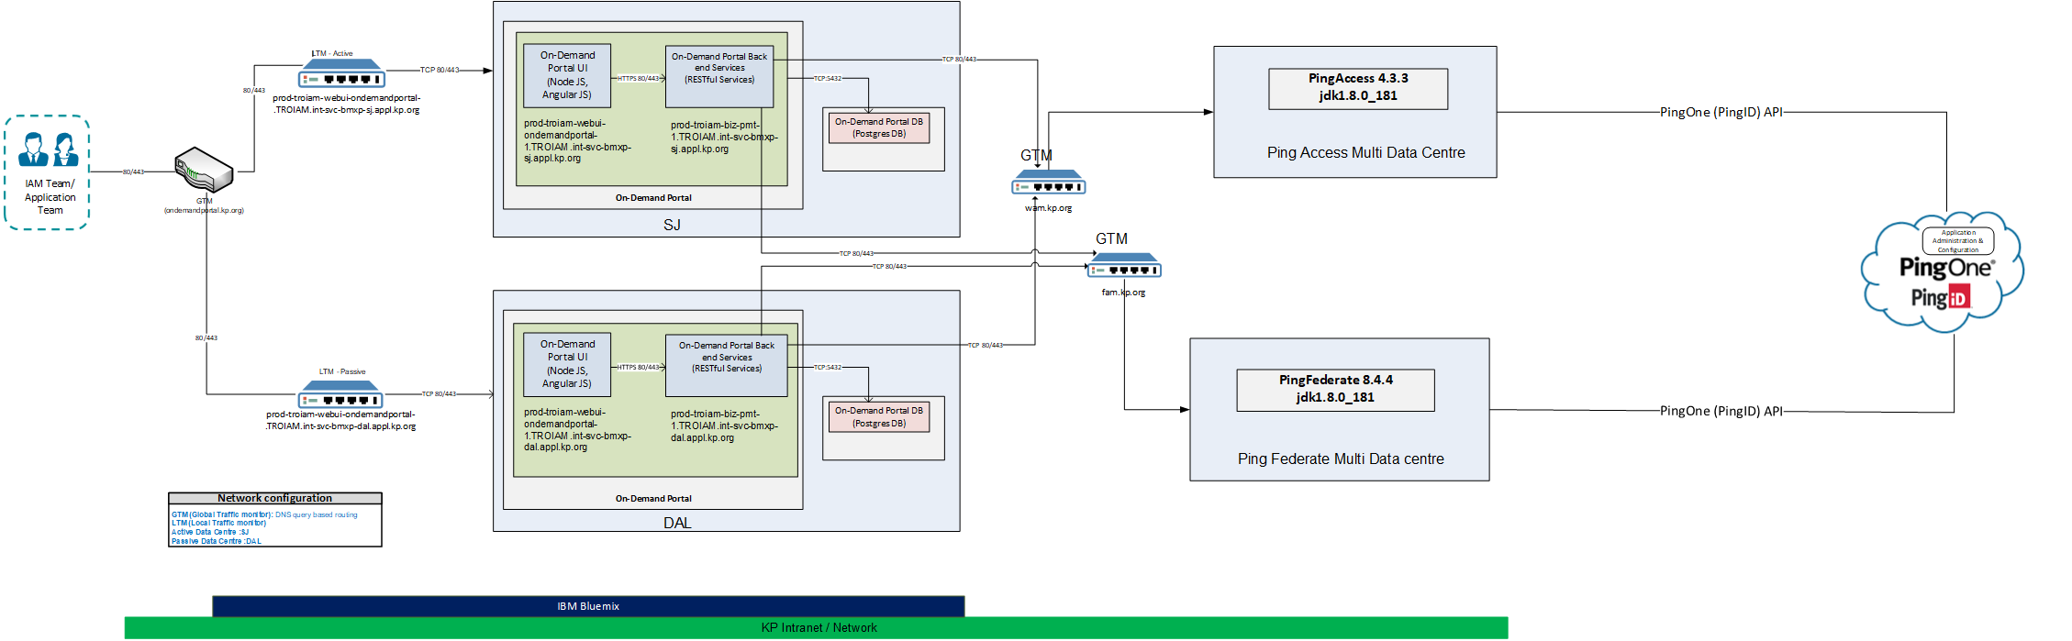

Other Design Considerations

Request for Deviations/Waivers
Not applicable

Specialized Testing Needs
On-Demand Portal will be tested in the Persistent System’s LAB environment which is created using PingAccess 4.3 and PingFederate 8.4.4, same versions as that of KP’s PingIdentity infrastructure.
However, these products will not be configured the same way as that of KP’s PingIdentity infrastructure. The configuration in Persistent Systems Lab will be limited to standard configuration required to test the artifacts created in PingAccess & PingFederate products.

Solution Auditing Considerations
Not in scope.

Appendix

Requirements Traceability
This table list all Project2018-Must-have and Project2018-Nice-to-have requirements from Requirement Definition Document. All future requirements are not considered at all.

Requirement ID are listed in the same sequence for better tracking however requirements that are future are not listed. Hence, at places the sequence will not be same. All requirements that are ‘Partially Met’ or ‘Not Met’ at all are listed towards the end of the table.

Req ID | Implementation (People & Process/  System / Both) | Met / Partially Met / Not Met | Realization(s) Impacted
ODP_FR1 | Both | Met | Access to Portal  Authentication  Access Control
ODP_FR2 | Both | Met | Roles & Responsibilities  Application Management  Request Management  Assessment  People and Process Design  Application Module / Services Details
ODP_FR3 | Both | Met | Assessment  Application Module / Services Details
ODP_FR4 | Both | Met | Automated Artifacts
ODP_FR5 | Both | Met | Automated Artifacts
ODP_FR6 | Both | Met | Provisioning to Non-PROD  Roles & Responsibilities  Promotion to PROD
ODP_FR7 | Both | Met | Roles & Responsibilities  Assessment Approval
ODP_FR8 | Both | Met | Request State Transition  Prod Promotion Event Response Diagram  Prod Promotion Details
ODP_FR9 | Both | Met | Roles & Responsibilities  Promotion to PROD
ODP_FR10 | Both | Met | Request State Transition  IAM Dashboard
ODP_FR12 | Both | Met | Request State Transition  Event Response Diagram
ODP_FR14 | System | Met | Email Notifications
ODP_FR21 | Both | Met | Roles & Responsibilities  Application Management  Request Management
ODP_FR22 | Both | Met | Request State Transition  Event Response Diagram
ODP_FR23 | Both | Met | Roles & Responsibilities
ODP_FR24 | Both | Met | Request State Transition  Request Management
ODP_FR27 | Both | Met | Automated Artifacts
ODP_FR28 | Both | Met | Upload Documents
ODP_FR29 | Both | Met | Application Management  ERD
ODP_FR30 | Both | Met | Application Management  ERD
ODP_FR31 | Both | Met | Application Management  ERD
ODP_FR32 | System | Met | Diagnostics
ODP_FR34 | System | Met | Application Management  ERD
ODP_FR35 | System | Met | PingAccess Web Session
ODP_FR11 | Both | Met | View SSO Configuration
ODP_FR13 | Both | Not Met | The Automated test suite must be designed and developed by the QA team. As there is no such automation that can be launched from the portal, this requirement to test the configuration will not be realized.
ODP_FR15 | System | Partially Met | OIDC/Oauth2.0 Automation  OIDC/Oauth are common integration models for Native apps. Portal will not support any Native Mobile application specific behavior however as the artifacts created could be used by mobile app, this requirement is partially met.
ODP_FR16 | Both | Met | Request State Transition  Roles & Responsibilities  Use Case 8: Fulfillment: Promotion to Prod IAM Deployment
ODP_FR25 | Both | Not Met | Request could be raised for different type of service, but configuration of existing service cannot be updated by raising new onboarding request for the very same service.  This will be added as future enhancement.
ODP_FR26 SLA | System | Not Met | This is nice to have requirement. MVP requirements have been given priority considering the timeline constraint.

Open Source Package Dependency

Libraries used by On-Demand Portal’s backend services
Sr. | Licenses | Files
1 | LGPL 2.1 | hibernate-commons-annotations-4.0.5.Final.jar  hibernate-core-4.3.6.Final.jar  hibernate-jpa-2.1-api-1.0.0.Final.jar
4 | BSD | dom4j-1.6.1.jar  antlr-2.7.7.jar
5 | Apache 2.0 | tomcat-jdbc-8.0.45.jar  tomcat-juli-8.0.45.jar  jackson-annotations-2.6.0.jar  jackson-core-2.6.3.jar  jackson-core-asl-1.9.13.jar  jackson-databind-2.6.3.jar  jackson-mapper-asl-1.9.13.jar  httpclient-4.5.2.jar  httpcore-4.4.4.jar  xml-apis-1.0.b2.jar  log4j-1.2.16.jar  jsr305-1.3.9.jar  jboss-logging-3.1.3.GA.jar  jboss-logging-annotations-1.2.0.Beta1.jar  jandex-1.1.0.Final.jar  j2objc-annotations-1.1.jar  guava-24.0-jre.jar  error_prone_annotations-2.1.3.jar  commons-beanutils-1.9.3.jar  commons-codec-1.10.jar  commons-collections-3.2.2.jar  commons-fileupload-1.3.1.jar  commons-io-2.4.jar  commons-lang3-3.5.jar  spring-aop-4.3.2.RELEASE.jar  spring-aspects-4.3.2.RELEASE.jar  spring-beans-4.3.2.RELEASE.jar  spring-context-4.3.2.RELEASE.jar  spring-core-4.3.2.RELEASE.jar  spring-data-commons-1.12.4.RELEASE.jar  spring-data-jpa-1.10.4.RELEASE.jar  spring-expression-4.3.2.RELEASE.jar  spring-hateoas-0.20.0.RELEASE.jar  spring-jdbc-4.3.2.RELEASE.jar  spring-ldap-core-2.1.0.RELEASE.jar  spring-orm-4.3.2.RELEASE.jar  spring-tx-4.3.2.RELEASE.jar  spring-web-4.3.2.RELEASE.jar  spring-webmvc-4.3.2.RELEASE.jar
 | Apache 2.0  LGPL 2.1  MPL 1.1 | javassist-3.18.1-GA.jar
6 | CDDL GPL 2.0 | jboss-transaction-api_1.2_spec-1.0.0.Final.jar
7 | MIT | slf4j-api-1.7.10.jar  slf4j-log4j12-1.7.10.jar  jcl-over-slf4j-1.7.10.jar  animal-sniffer-annotations-1.14.jar  mssql-jdbc-6.4.0.jre7.jar
8 | EPL 1.0 | aspectjweaver-1.8.9.jar  aspectjrt-1.8.9.jar
9 | GPL MIT | checker-compat-qual-2.0.0.jar

Packages used by UI
Sr. | Licenses | Files
1 | The MIT License (MIT) | NODE_MODULES  Async, bluebird, body-parser, connect-memcached, connect-mongo, connect-multiparty, express, express-session, fs-extra, lodash, lodash.transform, lusca,  mongoose, multiparty, nconf, path, Winston, winston-daily-rotate-file  ANGULAR_COMPONENTS  angular.min.js, angular-route.js, angular.panels.min.js, angular-ladda.min.js, checklist-model, ngLocalStorage, AxelSoft, multipleSelect, angularUtils, directives.dirPagination, ui.tree, ui.bootstrap
2 | Apache License 2.0 | NODE_MODULES  Request
3 | AGPL-3.0 | NODE_MODULES  Pm2
4 | Remark Theme Extended License  (Purchased by Persistent) | FRONT END COMPONENTS  font-awesome, weather-icons, web icons  animsition.css, bootstrap.min.css, bootstrap-extend.min.css, site.css, switchery.css, introjs.css, slidePanel.css, flag-icon.css, statistics.css, structure/testimonials.css, uikit/buttons.css, bootstrap-table.css,  bootstrap-tokenfield.css, bootstrap-tagsinput.css, bootstrap-select.css, formValidation.css, jquery-labelauty.css, jquery-labelauty-table.css, select2.css, panel-transition.css, typeahead.css, bootstrap-treeview.css, themify.css, ionicons.css, web-icons.min.css, brand-icons.min.css, asScrollable.css, alertify.js, animation.css, highlight.css, lightbox.css, masonry.css, rating.css, scrollable.css, toastr.css, calendar.css, contacts.css, documents.css, forum.css, location.css, mailbox.css, media.css, message.css, notebook.css, oig-work.css, projects.css, taskboard.css, work.css, chartist.css, chartjs.css, flot.css, pie-progress.css, sparkline.css, analytics.css, ecommerce.css, team.css, v1.css, v2.css, advanced.css, image-cropping.css, layouts.css, masks.css, validation.css, headers.css, page-aside-fixed.css, panel-transition.css, code-editor.css, gallery.css, maintenance.css, map.css, breadcrumbs.css, chat.css, navbars.css, ribbon.css, testimonials.css, timeline.css, datatable.css, jsgrid.css, badges-labels.css, buttons.css, carousel.css, colors.css, dropdowns.css, icon.css, icons.css, modals.css, panel-portlets.css, progress-bars.css, utilities.css, chart.css, data.css, social.css, statistics.css, weather.css, boeing.css  modernizr.js, breakpoints.js, jquery_005.js, bootstrap.js, jquery_002.js, jquery-asScroll.js, jquery_004.js, jquery.js, jquery-asHoverScroll.js, switchery_002.js, intro.js, screenfull.js, jquery-slidePanel.js, jquery_003.js, core.js, site.js, menu.js, menubar.js, gridmenu.js, sidebar.js, config-colors.js, config-tour.js, asscrollable.js, animsition.js, slidepanel.js, switchery.js, jquery-placeholder.js, jquery.mousewheel.js, jquery.asScrollable.all.js, jquery-asHoverScroll.js, jquery.form.min.js, switchery.min.js, screenfull.js, jquery-slidePanel.js, bootstrap-table.min.js, bootstrap-table-mobile.js, jquery-labelauty.js, formValidation.js, bootstrap.js, jquery.matchHeight-min.js, bootstrap-tokenfield.min.js, bootstrap-tagsinput.min.js, bootstrap-select.js, typeahead.jquery.min.js, bootstrap-datepicker.js, jquery.multi-select.js, bloodhound.min.js, bootstrap-treeview.min.js, jquery.dataTables.js, dataTables.fixedHeader.js, dataTables.bootstrap.js, dataTables.responsive.js, dataTables.tableTools.js, jquery.peity.min.js, xss.min.js, app.js, components.js, menu.js, menubar.js, gridmenu.js, sidebar.js, config-colors.js, config-tour.js, asscrollable.js, animsition.js, slidepanel.js, switchery.js, buttons.js, jquery-labelauty.js, matchheight.js, select2.js, animate-list.js, panel.js, panel-transition.js, bootstrap-tokenfield.js, bootstrap-tagsinput.js, bootstrap-select.js, bootstrap-datepicker.js,  multi-select.js, jquery-placeholder.js, bootstrap-treeview.js, treeview.js, selectable.js, selectable.js, bootbox.js, aspieprogress.js, datatables.js, peity.js,  responsive-tabs.js, closeable-tabs.js, tabs.js, table.js
5 | SurveyJS | https://surveyjs.io/Overview/Library/  MIT License

